# Impact of the 2014-16 marine heatwave on U.S. and Canada West Coast fisheries: surprises and lessons from key case studies

Christopher M. Free1,2*, Sean C. Anderson3, Elizabeth A. Hellmers4, Barbara A. Muhling5,6, Michael O. Navarro7, Kate Richerson8, Lauren A. Rogers9, William H. Satterthwaite10, Andrew R. Thompson5, Jenn M. Burt11, Steven D. Gaines1,2, Kristin N. Marshall12, J. Wilson White13, Lyall F. Bellquist14,15

1 Bren School of Environmental Science and Management, University of California, Santa Barbara, Santa Barbara, CA

2 Marine Science Institute, University of California, Santa Barbara, Santa Barbara, CA

3 Pacific Biological Station, Fisheries and Oceans Canada, Nanaimo, BC, Canada

4 California Department of Fish and Wildlife, Marine Region, La Jolla, CA

5 National Marine Fisheries Service, Southwest Fisheries Science Center, La Jolla, CA

6 Institute of Marine Sciences, University of California Santa Cruz, Santa Cruz, CA

7 Department of Natural Sciences, University of Alaska Southeast, Juneau, AK

8 National Marine Fisheries Service, Northwest Fisheries Science Center, Newport Field Station, Newport, OR

9 National Marine Fisheries Service, Alaska Fisheries Science Center, Seattle, WA

10 National Marine Fisheries Service, Southwest Fisheries Science Center, Fisheries Ecology Division, Santa Cruz, CA

11 Nature United, North Vancouver, BC, Canada

12 National Marine Fisheries Service, Northwest Fisheries Science Center, Seattle, WA

13 Coastal Oregon Marine Experiment Station and Department of Fisheries, Wildlife, and Conservation Sciences, Oregon State University, Newport, OR

14 The Nature Conservancy, Sacramento, CA

15 Scripps Institution of Oceanography, University of California, San Diego, San Diego, CA

**\* Corresponding author:** Bren School of Environmental Science and Management, University of California, Santa Barbara, 2400 Bren Hall, Santa Barbara, CA 93106-5131; [cfree@ucsb.edu](mailto:cfree@ucsb.edu)

**Short running title:** Fisheries lessons from a marine heatwave

**Two alternative titles:**

* Impact of the 2014-16 Northeast Pacific marine heatwave on U.S. and Canada West Coast fisheries: surprises and lessons from key case studies
* Fisheries management under extreme events: Surprises and lessons from the 2014-16 Northeast Pacific marine heatwave

## Abstract

Marine heatwaves are increasingly affecting marine ecosystems, with cascading impacts on coastal economies, communities, and food systems. Studies of heatwaves provide crucial insights into potential ecosystem shifts under future climate change and put fisheries social-ecological systems through “stress tests” that expose both vulnerabilities and resilience. The 2014-16 Northeast Pacific heatwave was the strongest and longest marine heatwave on record and resulted in profound ecological changes that impacted fisheries management and human livelihoods. Here, we synthesize the impacts of the 2014-16 marine heatwave on U.S. and Canada West Coast fisheries and extract key lessons for preparing global fisheries science, management, and industries for the future. We set the stage with a brief review of the impacts of the heatwave on marine ecosystems and the first systematic analysis of the economic impacts of these changes on commercial and recreational fisheries. We then examine ten key case studies that provide instructive examples of the complex and surprising challenges that heatwaves pose to fisheries social-ecological systems. These reveal important insights into improving the resilience of monitoring, management, and adaptive capacity to future stressors. Key recommendations include: (1) expanding monitoring to enhance mechanistic understanding, provide early warning signals, and improve predictions of impacts; (2) increasing the flexibility, adaptiveness, and inclusiveness of management where possible, and using simulation testing to help guide management decisions; and (3) enhancing the adaptive capacity of fishing communities by promoting engagement, flexibility, experimentation, and failsafes. These advancements are important as global fisheries prepare for a changing ocean.

**Keywords:** climate change, ocean warming, climate-adaptive management, climate-resilient fisheries, harmful algal blooms, ecological surprises

## 1. Introduction

Marine heatwaves have increased in frequency, duration, and intensity over the last century [(Oliver et al., 2018)](https://www.zotero.org/google-docs/?mAk8BX) and are expected to become even more common and severe under climate change [(Frölicher et al., 2018; Laufkötter et al., 2020)](https://www.zotero.org/google-docs/?2nn2eK). These discrete and extended periods of warm water anomalies [(Hobday et al., 2016)](https://www.zotero.org/google-docs/?Xpr0qn) can greatly impact marine ecosystems [(Smale et al., 2019)](https://www.zotero.org/google-docs/?VZSy0o) with cascading impacts on coastal economies, communities, and food systems [(Smith et al., 2021)](https://www.zotero.org/google-docs/?qQwWMm). Learning from past heatwaves is essential to building resilience to both future heatwaves and to directional warming for two key reasons. First, conditions during heatwaves are a harbinger of the future and provide insights on what to expect and how to prepare. Second, heatwaves put management systems and livelihoods through a “stress test” that exposes vulnerabilities and opportunities for increasing resilience.

As of 2022, the 2014-16 heatwave in the Northeast Pacific was the strongest and longest marine heatwave in recorded history [(Laufkötter et al., 2020)](https://www.zotero.org/google-docs/?hiYbVZ). It lasted >700 days, spanned >2.5 million km2 at its largest extent, and sea surface temperatures were, on average, >2.0°C above the climatological mean [(Gentemann et al., 2017)](https://www.zotero.org/google-docs/?wsv9xp). The heatwave occurred in one of the best monitored and managed regions of the world [(Gallo et al., 2022; Hilborn et al., 2020; Melnychuk et al., 2021)](https://www.zotero.org/google-docs/?tWOpI2), yet still greatly affected marine ecosystems and economies [(Cavole et al., 2016)](https://www.zotero.org/google-docs/?ENwHZb). For example, the heatwave caused (1) the loss of kelp forests and the abalone and urchin fisheries that depend on kelp [(Rogers-Bennett & Catton, 2019, p.)](https://www.zotero.org/google-docs/?gCJhEg); (2) an unprecedented harmful algal bloom that resulted in coastwide shellfish fishery closures [(McCabe et al., 2016)](https://www.zotero.org/google-docs/?oWXRLs); (3) a spike in humpback whale (*Megaptera novaeangliae*) entanglements resulting from increased overlap of whale foraging grounds with the Dungeness crab (*Metacarcinus magister*) fishery [(Santora et al., 2020)](https://www.zotero.org/google-docs/?KWDqps); and (4) recruitment failures for several fishery species [(Laurel & Rogers, 2020; McClatchie et al., 2016)](https://www.zotero.org/google-docs/?BJxKpJ). Learning from these impacts can bolster the resilience of monitoring programs, management systems, and fishing communities to the negative impacts of future heatwaves and climate change.

The heatwave also benefited many species [(Cavole et al., 2016)](https://www.zotero.org/google-docs/?lqaSk3), which present their own unique management challenges. For example, an explosion in the abundance of shortbelly rockfish (*Sebastes jordani*) in Oregon, a non-target bycatch species, required rapid management action to avoid the closure of the Pacific hake (*Merluccius productus*) fishery, which nearly exceeded its bycatch limit within the first two weeks of the season [(NMFS, 2020)](https://www.zotero.org/google-docs/?uHe5DS). Similarly, the northward expansion of California market squid (*Doryteuthis opalescens*) [(Chasco et al., 2022)](https://www.zotero.org/google-docs/?iRosT4) required rapid management action to regulate the newly emerging fishery in northern latitudes [(ODFW, 2021)](https://www.zotero.org/google-docs/?BUyaH9). In addition, movement of large Pacific bluefin tuna (*Thunnus orientalis*) into U.S. waters during the heatwave was a boon for recreational fishing [(Runcie et al., 2019)](https://www.zotero.org/google-docs/?lgAf5n). However, it increased fishing mortality on this already overfished stock and highlighted an incomplete understanding in the relationship between local availability and stockwide abundance. Flexible, agile, and informed management is thus crucial to preparing coastal communities for both positive and negative climate impacts.

Here, we synthesize the impacts of the 2014-16 marine heatwave on fishing communities along the West Coast of the United States and Canada and extract key lessons for preparing fisheries science, management, and industries for future climate change and heatwaves based on this experience. We set the stage with a brief review of the impacts of the heatwave on the ecosystem and the first systematic analysis of the economic impacts of these changes on commercial and recreational fisheries. This analysis examines the change in commercial fisheries revenues and recreational fisheries landings that occurred during and after the heatwave relative to before the heatwave. We then examine ten key case studies that provide instructive examples of the complex, and often surprising, challenges that heatwaves pose to fisheries social-ecological systems. These reveal important insights into improving the resilience of monitoring, management, and adaptive capacity to future stressors.

## 2. The 2014-16 marine heatwave

The marine heatwave began in fall 2013 as a large “blob” of anomalously warm water in the Gulf of Alaska (**Figure 1**) [(Bond et al., 2015)](https://www.zotero.org/google-docs/?11M836). This warm pool began to spread south in spring 2014 and encompassed the entire California Current ecosystem by late 2014. The pool formed as a result of an unusually persistent ridge of high atmospheric pressure that suppressed zonal winds, limited heat loss from surface waters, and reduced advection of cooler water into the upper ocean [(Bond et al., 2015)](https://www.zotero.org/google-docs/?QIyvcQ). It persisted as a result of a strong El Niño that began in mid-2015 and caused warm conditions to last until summer 2016 in the California Current [(Di Lorenzo & Mantua, 2016; Jacox et al., 2016)](https://www.zotero.org/google-docs/?gZZfS8) and through 2017 in the Gulf of Alaska [(Suryan et al., 2021)](https://www.zotero.org/google-docs/?PGfOfu). Throughout this period, anomalously warm conditions only abated in spring in nearshore upwelling zones under favorable wind stress [(Gentemann et al., 2017)](https://www.zotero.org/google-docs/?3OOXpg). However, cool, nutrient-rich, subarctic source water was locally available before and during the heatwave [(Schroeder et al., 2019)](https://www.zotero.org/google-docs/?P6wOOS). Additionally, the high-pressure conditions that initiated the heatwave weakened typical winter storm and wind patterns [(Whitney, 2015)](https://www.zotero.org/google-docs/?KPgIYW). This resulted in persistent stratification of the surface layer, and a reduction in upwelling-favorable alongshore winds. Increased stratification and reduced upwelling limited the vertical mixing of cold, nutrient-rich, deep water into surface waters, leading to reduced nutrient fluxes into the euphotic zone and deepening of the nutricline in 2014-15 [(Zaba & Rudnick, 2016)](https://www.zotero.org/google-docs/?9l5FKi).

These physical changes had profound impacts on plankton communities throughout the California Current ecosystem. In nearshore waters, enhanced stratification reduced nutrient renewal, leading to low phytoplankton abundance [(Delgadillo-Hinojosa et al., 2020; Peña et al., 2019; Whitney, 2015)](https://www.zotero.org/google-docs/?CnD8Fc). However, in offshore waters, increased stratification increased effective light levels in the surface layer and increased production in an area normally co-limited by iron and light [(Peña et al., 2019)](https://www.zotero.org/google-docs/?PNOR5W). These conditions contributed to a harmful algal bloom of unprecedented size, duration, and intensity, leading to widespread fishery closures and contributing to mass mortalities of seabirds and marine mammals [(McCabe et al., 2016; McKibben et al., 2017)](https://www.zotero.org/google-docs/?gyh8Cv). The bloom, composed of diatoms in the *Pseudo-nitzschia* genus, was induced through a perfect storm of events. First, anomalously warm conditions allowed *Pseudo-nitzschia*, which is tolerant to low nutrient levels, to thrive in warm, nutrient-poor, offshore waters north of its typical range. Then, a series of seasonal storms transported the offshore bloom to the coast, where seasonal upwelling injected nutrients that further intensified the bloom [(McCabe et al., 2016)](https://www.zotero.org/google-docs/?0qyxI5). As for the zooplankton community, abundance remained high throughout the heatwave, but with dramatic changes in composition. In general, there was a surge in warm-water species from southern and offshore waters, an increase in the abundance of gelatinous zooplankton, and a decrease in the abundance of crustacean holoplankton, particularly krill [(Batten et al., 2022; Brodeur et al., 2019; Lilly & Ohman, 2021; McKinstry et al., 2022; Peterson et al., 2017; Thompson et al., 2022)](https://www.zotero.org/google-docs/?FeYKtr). The dominance of lipid-poor warm-water zooplankton relative to lipid-rich cool-water zooplankton likely contributed to lower productivity in higher trophic levels [(Peterson et al., 2017)](https://www.zotero.org/google-docs/?zWLqce).

The heatwave induced many changes to higher trophic-level species. In general, the ranges of southern warm-water fish and large invertebrates extended northward, and the ranges of offshore warm-water species extended inshore as waters warmed coastwide [(Thompson et al., 2022)](https://www.zotero.org/google-docs/?iotEGF). Interestingly, many cool-water species generally appeared to persist within their historical geographic ranges, likely due to the presence of pockets of cool water [(Sanford et al., 2019)](https://www.zotero.org/google-docs/?XxBoDj). The heatwave also induced shifts, both positive and negative, in the productivity of many ecologically and economically important fish species [(Cavole et al., 2016)](https://www.zotero.org/google-docs/?FySduY). For example, while rockfish (*Sebastes* spp.) and Northern anchovy (*Engraulis mordax*) recruitment was high during the heatwave, Pacific sardine (*Sardinops sagax*) and salmon recruitment was low [(Munsch et al., 2022; Schroeder et al., 2019; Thompson et al., 2022)](https://www.zotero.org/google-docs/?nu4iOz); hypothesized mechanisms are discussed in greater detail in the case studies below. Furthermore, the heatwave reduced the nutrient content of key forage fish species as result of shifts in the availability of their prey [(Mantua et al., 2021; von Biela et al., 2019)](https://www.zotero.org/google-docs/?DRnyOX). In some cases, changes in the abundance, composition, and nutrient content of forage fish triggered the mass mortality of marine mammals [(NMFS, 2022)](https://www.zotero.org/google-docs/?4ximDV) and seabirds [(Drever et al., 2018; Jones et al., 2018, 2019; Piatt et al., 2020, p. 2)](https://www.zotero.org/google-docs/?ixJapz). In other cases, high recruitment of anchovy and other fishes during the marine heatwave fueled marine mammals and seabird population growth that have persisted to at least 2021 [(Thompson et al., 2022)](https://www.zotero.org/google-docs/?aBXyLI).

## 3. Socioeconomic impacts of the heatwave on fisheries

The socioeconomic impacts of the heatwave on commercial, recreational, and Indigenous fisheries are documented for some high profile fisheries suffering large negative impacts, but have not been systematically quantified for the majority of the coast’s fisheries. In the United States, federal fisheries disasters were declared as a result of the heatwave for commercial and Indigenous fisheries targeting Dungeness crab and rock crab (*Cancer* spp.), Pacific sardine, red sea urchin (*Mesocentrotus franciscanus*), and many salmon stocks (**Figure 2**), resulting in over US$141 million in relief to impacted fishers, processors, and dealers [(Bellquist et al., 2021)](https://www.zotero.org/google-docs/?PWtXwm). Among these disaster declarations, the largest appropriation (US$56.3 million) was to the Gulf of Alaska pink salmon (*Oncorhynchus gorbuscha*) industry following low salmon returns attributed to poor oceanographic conditions [(Pritzker, 2017a)](https://www.zotero.org/google-docs/?Xmgc1f). The second largest appropriation (US$25.8 million) was to the California Dungeness crab industry following extended fishery closures due to harmful algal blooms [(Pritzker, 2017b)](https://www.zotero.org/google-docs/?BODO1z). Amongst recreational fisheries, negative economic impacts are best documented for razor clams (*Siliqua patula*) [(Ekstrom et al., 2020; Moore et al., 2019; Ritzman et al., 2018)](https://www.zotero.org/google-docs/?GZJaCj), which support large tourist economies in Oregon and Washington [(Dyson & Huppert, 2010)](https://www.zotero.org/google-docs/?FyEebi). The 2015 harmful algal bloom caused widespread closures in both states causing an estimated loss of US$22 million in tourism revenues [(Mapes, 2015)](https://www.zotero.org/google-docs/?rVC23k). In addition to causing increased financial hardship, these events contributed to increased emotional stress and reduced sociocultural well-being [(Moore et al., 2020, p. 96)](https://www.zotero.org/google-docs/?t0qHxO).

To provide the first systematic overview of the potential economic impacts of the heatwave on the commercial fisheries of the U.S. and Canada West Coast, we compared revenues during (2014-2016) and after the heatwave (2017-2019) with revenues before the heatwave (2011-2013) using commercial landings data (see supplemental information). To account for inflation, we adjusted all revenues to 2020 U.S. dollars. This analysis is limited in that it cannot attribute causality, it does not account for lags in heatwave impacts, and it assumes that profits are proportional to revenues, but it still provides useful insights into the identity and rank order of potential heatwave “winners” and “losers”. We found that fleetwide revenues fell during the heatwave in California and Alaska, were stable in Oregon and Washington, and increased in British Columbia. The largest decreases occurred in California (**Figure 3A**), largely due to exceptionally high revenue losses in California’s Dungeness crab, Pacific sardine, and market squid fisheries (**Figure 3B)**. Whereas a small dip in revenues rebounded to pre-heatwave levels in Oregon and Washington, revenues remained low in both Alaska and California throughout the three years following the heatwave (**Figure 3A**). British Columbia experienced higher revenues after the heatwave than in either the periods before or during the heatwave, largely driven by increase in revenues from coastal pelagic species. All four U.S. states saw revenue losses in coastal pelagic fisheries and significant revenue increases in shrimp fisheries during the heatwave. Only California saw increases in revenues in fisheries for highly migratory species during the heatwave, and only Oregon saw increases in revenues from bivalve fisheries (**Figure 3B).** Among management groups with reduced revenues during the heatwave, recovery to pre-heatwave revenues only occurred in Oregon and Washington’s Dungeness crab fisheries and British Columbia’s salmon fisheries. Species-specific results show an array of winners and losers, illustrating the complex heterogeneity of heatwave impacts (**Figure 4**).

We performed a similar analysis on recreational fisheries landings using estimates of the number of fish retained across all fishing modes (e.g., charter boats, private boats, jetties, piers, beaches, etc.) (see supplemental information). Recreational fisheries are significantly larger in California than in British Columbia or the other U.S. states (**Figure 5**). Overall, recreational landings in California declined during and after the heatwave, though this may be part of a longer-term trend (**Figure 5A**). Declines during the heatwave were driven by large declines in coastal pelagic species (e.g., sardine, anchovy), flatfish, and other miscellaneous species and were only slightly offset by large increases in tuna, roundfish (e.g., sablefish, hake, cod), surfperch, and rockfish (**Figure 5B**). Overall, recreational landings in Oregon, Washington, and Alaska have been relatively constant through time and even increased during the heatwave (**Figure 5A**). In these states, increased landings were apparent in every species group except sharks and rays and the “other fish” category (**Figure 5B**). As with commercial fisheries revenues, species-specific results show a diversity of complex impacts (**Figure 6**).

Indigenous fisheries in the Pacific Northwest are especially vulnerable to climate change [(Koehn et al., 2022)](https://www.zotero.org/google-docs/?J91hb6) and it is likely that they were disproportionately impacted by the heatwave. Although limited availability of Indigenous landings and revenue data in public databases precludes impact analyses like those described above, U.S. federal fishery disaster declarations provide some indication of the socioeconomic impacts of the heatwave on Native American fisheries (note: First Nation fisheries are not considered here because Canada does not have an analogous disaster relief program). Tribal fishery disaster declarations, primarily occurring among salmon fisheries, increased significantly beginning in 2017 as the impacts of the heatwave were fully realized [(Bellquist et al., 2021)](https://www.zotero.org/google-docs/?5OkjIS). Fifteen individual tribes were identified as being impacted by these disasters, as well as four tribal associations that represent approximately two hundred tribes across the Pacific Northwest and Alaska [(Bellquist et al., 2021)](https://www.zotero.org/google-docs/?FvJiMY). Overall, between US$111-188 million was appropriated to tribal fishing communities as a result of the marine heatwave. However, disaster declarations do not fully capture the complex and profound nature of impacts to Indigenous fisheries, which provide significant sociocultural and subsistence values [(Crosman et al., 2019)](https://www.zotero.org/google-docs/?xFk1Z9). More cooperative research is necessary to characterize and mitigate the impacts of climate change and heatwaves on Indigenous communities.

## 4. Case studies

In this section, we present ten key case studies that provide instructive examples of the complex, and sometimes surprising, challenges that heatwaves pose to fisheries social-ecological systems and reveal important insights into improving the resilience of monitoring, management, and adaptive capacity to future stressors (**Figure 7**). These case studies represent a diversity of management regimes (international, federal, state), sectors (commercial, recreational, Indigenous), and taxonomic groups (finfish, crabs, shrimp, squid, abalone, urchins). Case studies were selected to describe both positive and negative heatwave impacts. The five case studies focused on negative impacts include five fisheries that received U.S. federal disaster relief as a result of the heatwave: Pacific cod (*Gadus macrocephalus*), Chinook salmon (*Oncorhynchus tshawytscha*), Dungeness crab, urchin/abalone, and Pacific sardine. The five case studies focused on positive impacts were selected based on common examples from the literature (California market squid, Pacific bluefin tuna, two rockfish species; see Cavole et al. 2016) and a prominent example from this study’s data analysis (shrimp). In each case study, we provide a brief overview of the fishery, the impact of the heatwave on the fishery, the response of industry and management to these impacts, and the revealed opportunities for improving resilience to future heatwaves and climate change.

### 4.1. Pacific cod

Pacific cod has long supported a productive commercial fishery in the Gulf of Alaska. However, in 2017, a sudden and severe decline in biomass was detected that could not be explained by harvest alone [(Barbeaux et al., 2021)](https://www.zotero.org/google-docs/?jn0X6W). Rather, the stock experienced the double impact of increased adult mortality and sustained low recruitment, both linked to the heatwave. High mortality of adult cod was associated with poor body condition [(Barbeaux et al., 2020)](https://www.zotero.org/google-docs/?dBY8I4) as a result of reduced prey availability and increased metabolic demands by predators during the heatwave [(Piatt et al., 2020; Rogers et al., 2021; von Biela et al., 2019)](https://www.zotero.org/google-docs/?rtfjl9). Simultaneously, warm thermal conditions at depth likely reduced egg survival and recruitment [(Laurel & Rogers, 2020)](https://www.zotero.org/google-docs/?sbAMJv). Heatwave conditions returned in 2019, further depressing recruitment and delaying recovery of the stock. The sharp stock decline in 2017 resulted in severe reductions to catch limits for 2018 and 2019. However, the stock continued to decline, and the North Pacific Fisheries Management Council closed the directed federal Pacific cod fishery for 2020 [(Barbeaux et al., 2021)](https://www.zotero.org/google-docs/?k79L1e) (**Figure 8E**). Impacts to fishing communities were significant, and ultimately, a U.S. federal fisheries disaster was declared. By 2022, the stock was increasing, but catch limits were still a small fraction of pre-heatwave levels.

The management response to the dramatic stock declines reflects the system of ecosystem-based fisheries management in Alaska and highlights lessons for fisheries management under rapidly changing climate conditions. First, precautionary buffers, which reduce catch limits from the maximum allowable, have a precedent for use when ecosystem conditions raise red flags for a stock that are not captured in the stock assessment process [(Dorn & Zador, 2020)](https://www.zotero.org/google-docs/?y96aju). Such reductions were made in 2018, 2019, and 2020. The continued incorporation of ecosystem information into the management process can allow managers to respond precautionarily, but requires effective monitoring and research to be most effective [(Peterson Williams et al., 2022)](https://www.zotero.org/google-docs/?8PleM2). Second, a forward-looking perspective is needed: for instance, recruitment projections based on historical observations become less informative as we encounter unprecedented ocean conditions [(Litzow et al., 2021)](https://www.zotero.org/google-docs/?SWEOP6). Early warning indicators can enable proactive management in the case of rapid ecosystem or stock shifts [(Litzow et al., 2022)](https://www.zotero.org/google-docs/?1LxKr2). Finally, climate-linked stock assessment approaches (e.g., [Barbeaux et al., 2021)](https://www.zotero.org/google-docs/?yJIOvo) will be important for proactively responding to future heatwaves and other extreme events.

### 4.2. Chinook salmon

Chinook salmon range from central California to Alaska and support Indigenous, commercial, and recreational fisheries of considerable economic [(Richerson et al., 2018)](https://www.zotero.org/google-docs/?oVLqym), subsistence [(Poe et al., 2015)](https://www.zotero.org/google-docs/?OVHZ9T), and cultural [(Campbell & Butler, 2010)](https://www.zotero.org/google-docs/?wPhFGU) value. Ocean Chinook salmon fisheries south of Cape Falcon, Oregon are primarily regulated using harvest control rules that limit harvests in ways expected to achieve escapement goals based on forecasts of preseason abundance for both the Sacramento and Klamath River Fall Chinook stocks. In general terms, both forecast models are based on the previous year’s returns [(Peterman, 1982; Winship et al., 2015)](https://www.zotero.org/google-docs/?CuTBZN); they do not explicitly include environmental covariates despite their known importance [(Friedman et al., 2019; Wells et al., 2016)](https://www.zotero.org/google-docs/?K0vD3r). The marine heatwave impacted juveniles entering the ocean in 2014-16 from both these stocks, with cohorts predominantly returning as adults in 2016-18 in the Sacramento and 2017-2019 in the Klamath River. Both stocks’ models forecasted low preseason abundance, but both also nonetheless overestimated actual return size (**Figure 8D**). In the Klamath River, the 2016 run size was the lowest since 1983 and the 2017 run size was the third-lowest (1992 was lower). In the Sacramento River, 2016 escapement was below average and 2017 escapement was the second-lowest since 1983. As a result of low escapements, both stocks were declared overfished in 2018. Following both restricted fishing opportunity (based on low preseason abundance forecasts) and low abundance of harvestable fish, harvests and incomes were greatly reduced and several federal fishery disasters were declared, impacting all fishery sectors, including both commercial harvesters and the Klamath Basin tribes. These disasters were attributed to the marine heatwave and simultaneous extreme drought conditions that resulted in warmer river temperatures and anomalously low water levels, particularly on the Klamath River [(PFMC, 2019a, 2019b)](https://www.zotero.org/google-docs/?6r3U7m). While catch limits were adjusted downwards in response to low preseason abundance forecasts, they were not reduced as much as they would have been if the impacts of the heatwave (and other factors) had been perfectly forecast. Thus, optimistic model forecasts and/or insufficiently precautionary control rules may have contributed to overharvest and the eventual overfished designation. This suggests that improved forecasts and control rules could ameliorate overharvest risk; however, even with perfect foresight, poor environmental conditions still lead to loss in commercial revenues, recreational fishing opportunities, and cultural and subsistence benefits in Indigenous fisheries [(O’Rourke, 2018; PFMC, 2018, 2019b)](https://www.zotero.org/google-docs/?sZsVio). This highlights the importance of restoring freshwater habitats to buffer against poor ocean conditions and increasing community resilience through additional policy actions that, for example, promote the ability to switch to alternative fisheries or reform disaster relief to be more accurate, timely, and equitable.

### 4.3. Kelp, urchin, abalone

In 2015, a perfect storm of stressors tipped some bull kelp (*Nereocystis luetkeana*) forests into unproductive urchin barrens in northern California, ultimately causing the collapse of the recreational abalone and commercial urchin fisheries, as both species are kelp herbivores [(Rogers-Bennett & Catton, 2019)](https://www.zotero.org/google-docs/?CDfWIm). This began in the summer of 2013 when Sea Star Wasting syndrome caused a massive die-off of sunflower sea stars (*Pycnopodia helianthoides*), an important predator of urchins in kelp forest ecosystems [(Harvell et al., 2019)](https://www.zotero.org/google-docs/?tzDPHZ). Then, in 2014, warm waters and nutrient limitation throughout the summer growing season likely suppressed kelp growth and spore production, reducing productivity [(Rogers-Bennett & Catton, 2019)](https://www.zotero.org/google-docs/?31uXCg). As a result of reduced productivity and increased urchin grazing pressure following a sea star predation release, bull kelp forests were reduced by >90% along the northern California coast [(McPherson et al., 2021; Rogers-Bennett & Catton, 2019)](https://www.zotero.org/google-docs/?tiRwNK). In 2015, the loss of kelp forage resulted in the collapse of the commercial red sea urchin fishery. While the abundance of red sea urchins, which are marketed for their roe, remained high, starvation due to lack of kelp led to poor gonad production and unmarketable urchins. This collapse was declared a federal fisheries disaster and $3.3 million in disaster relief was distributed to impacted fishers, processors, and dealers [(Bellquist et al., 2021)](https://www.zotero.org/google-docs/?Fd3KTb). In 2017, the mass mortality of red abalone (*Haliotis rufescens*) due to starvation (kelp is the primary food resource for abalone) led to the closure of the recreational abalone fishery in California and Oregon (**Figure 8C**), which previously supported an estimated 35,000 participants and the infusion of $24-44 million annually into local economies [(Reid et al., 2016)](https://www.zotero.org/google-docs/?txYP6b). The fishery remains closed at the time of writing (Oct 2022). Active recovery facilitated by reductions in urchin grazing pressure and enhancements to kelp growth could increase the resilience of kelp forests and the fisheries they support to climate change [(Hamilton et al., 2022; Hohman, 2019)](https://www.zotero.org/google-docs/?DCgge1). The first could involve encouraging new fisheries for purple sea urchin (*Strongylocentrotus purpuratus*), which are less attractive than red urchins because they are smaller, have smaller gonads (the product that is marketed), and require more effort to harvest and process [(Parker & Ebert, 2003)](https://www.zotero.org/google-docs/?fApxkz). The latter might involve area-based protection or active restoration through seeding [(Arroyo-Esquivel et al., 2022)](https://www.zotero.org/google-docs/?Yah0De). Restoration is expensive and may require developing innovative strategies for financing the restoration of these vital ecosystems [(Eger et al., 2020)](https://www.zotero.org/google-docs/?SVh0eX).

### 4.4. Dungeness crab

The Dungeness crab fishery is the U.S. West Coast’s most lucrative commercial fishery and is the central source of income for a large proportion of fishers coastwide [(Fuller et al., 2017)](https://www.zotero.org/google-docs/?kMBNLy). Historically, this fishery has been managed profitably and sustainably by limiting harvest to large male crabs during a November-August season (Richerson et al., 2020). However, the heatwave significantly disrupted this fishery through two indirect pathways. First, the 2015-16 harmful algal bloom triggered widespread fishery closures due to unsafe levels of biotoxins in crabs (**Figure 8A**). Closures were especially harmful in California, extending from the traditional November start of the season into mid-April [(McCabe et al., 2016)](https://www.zotero.org/google-docs/?gpl9H3). As a result, the 2015-16 season was declared a federal fisheries disaster and $25.8 million in disaster relief was allocated to impacted fishers, processors, and dealers, though not until over three years later [(C. Bonham, personal communication, July 19, 2018)](https://www.zotero.org/google-docs/?oC2qX6). When indirect losses from other fisheries were included, the delay was associated with over $43 million in lost income [(Holland & Leonard, 2020)](https://www.zotero.org/google-docs/?yGtIYN). Second, the delayed opening of the fishery and the heatwave-induced nearshore compression of coastal upwelling increased the overlap between fishing and the foraging grounds of returning humpback whales, causing a dramatic spike in entanglements of whales in crab pot lines, especially in California [(Santora et al., 2020)](https://www.zotero.org/google-docs/?bnypD5). This precipitated a lawsuit by the Center for Biological Diversity alleging that California’s management of the Dungeness crab fishery threatened endangered species and was non-compliant with the Endangered Species Act (CA-DOJ 2017). These events prompted an overhaul of California’s entanglement risk management program (CDFW 2020), which has implemented early closures in the last four fishing seasons (2018-19 to 2021-22) to reduce entanglement risk, but at significant cost to fishers [(Seary et al., 2022)](https://www.zotero.org/google-docs/?ZJdtbx). Increasing the resilience of the Dungeness crab fishery could be advanced by: (1) expanding the spatial-temporal scale of biotoxin monitoring to enable surgical closures that protect public health with the least impacts on fishers [(Free, Moore, et al., 2022)](https://www.zotero.org/google-docs/?7zhUaa); (2) developing entanglement prevention strategies that are proven to be effective, robust or adaptable to changing conditions, and co-developed with stakeholders [(Samhouri et al., 2021)](https://www.zotero.org/google-docs/?9qWbKl); (3) reforming the federal fisheries disaster program to enable fast, accurate, and equitable relief [(Bellquist et al., 2021)](https://www.zotero.org/google-docs/?w1rKXn); and (4) easing access to alternative fisheries as a means of diversifying fishing opportunities [(Oken et al., 2021)](https://www.zotero.org/google-docs/?3PIuny) and potentially escaping the “gilded trap” presented by the lucrative, yet volatile, Dungeness crab fishery [(Fisher et al., 2021)](https://www.zotero.org/google-docs/?YnzvJz).

### 4.5. Pacific sardine and northern anchovy

Pacific sardine and northern anchovy have historically been two of the most abundant and ecologically important forage fish species in the California Current. Populations of both species are characterized by highly variable “boom-and-bust” cycles, even in the absence of fishing [(McClatchie et al., 2018)](https://www.zotero.org/google-docs/?hFIcc1). For many decades, this variability was believed to relate to basin-scale oceanographic regimes (e.g., as characterized by the Pacific Decadal Oscillation), with warm conditions favoring sardine and cool conditions favoring anchovy [(Chavez et al., 2003)](https://www.zotero.org/google-docs/?BUWWO2). Several hypotheses were proposed to explain this apparent relationship. While some studies suggest that anchovy larvae are more tolerant of cold water than sardine larvae [(Lasker, 1964; Lluch-Belda et al., 1991)](https://www.zotero.org/google-docs/?wnxvqc), others suggest that stronger upwelling during warm periods may favor the small planktonic prey preferred by adult sardine [(Rykaczewski & Checkley, 2008)](https://www.zotero.org/google-docs/?2N03ao). However, the paradigm of warm conditions favoring sardine has been upended over the past two decades. Although it was predominantly cool from 1999-2013, anchovies were abundant during warm conditions from 2004-06 and remained scarce during the other cool years [(Sydeman et al., 2020)](https://www.zotero.org/google-docs/?s5GvHT). Moreover, the heatwave was expected to help recover the declining sardine population and curb growth in the increasing anchovy population; instead, sardine abundance continued to decline throughout the heatwave [(Nielsen et al., 2021)](https://www.zotero.org/google-docs/?c10Mtc), contributing to the closure of the directed fishery in 2015 (**Figure 8B**), and anchovy abundance rose to near record highs [(Thompson et al., 2022)](https://www.zotero.org/google-docs/?J1dLmF). Although the environmental mechanisms driving fluctuations in sardine and anchovy abundance remain poorly resolved, [(Swalethorp et al., 2022)](https://www.zotero.org/google-docs/?suiiQ8) found that changes in larval anchovy diet explained a significant proportion of spawning stock biomass two years later. Shifting anchovy and sardine dynamics illustrate the risks of relying on historical statistical correlations to guide management decisions, as climate change increasingly results in no-analog conditions in ecosystems such as the California Current. Although anchovy do not support substantial fisheries, their high biomass inshore likely contributed to increased entanglements of humpback whales with crab fishing gear [(Santora et al., 2020)](https://www.zotero.org/google-docs/?zSr2hI), but also appears to have led to a trend of more and healthier sea lion pups since 2016 in the California Channel Islands [(Weber et al., 2021)](https://www.zotero.org/google-docs/?jrCOOw) and successful nesting of resident seabirds on Southeast Farallon Island (Fennie et al. in review). While the heatwave did not trigger the initial decline in sardine biomass, the lack of recovery of this species continued to cause loss of revenue for direct commercial fisheries, and for the live-bait fishery supporting recreational fishers [(PFMC, 2020, p.)](https://www.zotero.org/google-docs/?ZQYenE). Successfully managing these species under future climate conditions will require a better understanding of the links between complex environmental changes (beyond temperature alone), foraging ecology, and productivity of the stock, and/or using management strategies that are robust to these dynamics [(Siple et al., 2019)](https://www.zotero.org/google-docs/?jeHHOw).

### 4.6. Shortbelly rockfish

Shortbelly rockfish are an important prey species for seabirds and marine mammals in the California Current, and a non-target bycatch species in the commercial rockfish and Pacific hake trawl fisheries. In 2018, the explosion of shortbelly rockfish abundance following high recruitment during the marine heatwave nearly caused the closure of the hake fishery. In 2001, the Pacific Fisheries Management Council (PFMC) established a catch limit for shortbelly rockfish based on the belief that a commercial fishery would develop [(Field et al., 2007)](https://www.zotero.org/google-docs/?bPGfok). Although a directed fishery did not emerge, catch limits remain in place. Historically, shortbelly bycatch in the hake fishery has not approached the catch limit, but this changed radically as a result of the heatwave. Within the first two weeks of the 2018 fishing season, the commercial hake fishery off Oregon encountered several shortbelly bycatch hotspots and came very close to exceeding the annual catch limit (**Figure 9A**). Without management intervention, the high catch of shortbelly rockfish threatened to shut down the hake fishery at the very beginning of its season. To make a rapid but informed decision, the PFMC examined recruitment estimates from NOAA’s Rockfish Recruitment and Ecosystem Assessment Survey [(Sakuma et al., 2015)](https://www.zotero.org/google-docs/?kLFqAj). They found that recruitment increased for most rockfish species during the heatwave and that shortbelly recruitment jumped an order of magnitude above other rockfish winners. This was likely due to the predominance of subarctic source water in upper depths (100-400 m) over the outer shelf-slope where many rockfish spawn; that water is generally cooler, fresher, and more oxygenated than other source waters and is correlated with high rockfish recruitment [(Schroeder et al., 2019)](https://www.zotero.org/google-docs/?GD9v8w). As the fastest-lived rockfish (i.e., fast growth, early age at maturity, high mortality; [Love et al., 2002)](https://www.zotero.org/google-docs/?aLfPhN), shortbelly rockfish were probably particularly poised to benefit from these favorable conditions [(Field et al., 2007; Pearson et al., 1991)](https://www.zotero.org/google-docs/?Q9iCtL). As a result of these massive recruitment events, shortbelly abundance was likely higher than it had been in decades. After considering this best available science and statements from advisory bodies and the public, the PFMC decided to raise the catch limit for the 2018 season, saving the hake fishery from early closure. This case study highlights the importance of fishery-independent monitoring of all life stages for detecting and explaining ecological surprises as well as the importance of nimble and flexible management that is responsive to such surprises.

### 4.7. California market squid

The heatwave triggered significant range expansions and geographical shifts in the productivity of California market squid, which have persisted beyond the heatwave years and resulted in emerging fisheries in sudden need of management. Historically, the range of market squid has been concentrated in California, where it supports one the state’s largest and most valuable fisheries [(Free, Vargas Poulsen, et al., 2022)](https://www.zotero.org/google-docs/?oywNYJ). In the past, strong El Niño conditions have supported temporary (i.e., weeks long) extensions of market squid range as far north as the Gulf of Alaska. However, the 2014-16 marine heatwave resulted in an especially pronounced northward shift that has persisted for a longer duration than ever recorded [(Burford et al., 2022; Chasco et al., 2022; M. Navarro, 2020)](https://www.zotero.org/google-docs/?nDm02j). From 2016-2020, California’s landings fell by more than 50% relative to the previous 5 years, while Oregon’s landings increased by orders of magnitude (**Figure 9B**). During the same time period, squid observations increased throughout the Gulf of Alaska, with squid spawning as far as Kodiak Island [(M. O. Navarro et al., 2018)](https://www.zotero.org/google-docs/?d83Yxx) and adults seen as far as the Shumagin (East Aleutian) Islands [(Eiler, 2021)](https://www.zotero.org/google-docs/?MUvced). The development of a significant squid fishery in Oregon has led to several proposed fishery regulations, particularly in response to concerns over conflicts with other fishing gears (e.g., Dungeness crab pots), bycatch (e.g., Dungeness crab and salmon), and impacts on benthic habitats [(ODFW, 2021)](https://www.zotero.org/google-docs/?mHrYjA). Similarly, a proposal for a new market squid fishery in Alaska was submitted in 2017 [(Peeler, 2018)](https://www.zotero.org/google-docs/?XjPVyG), but was not passed due to concerns over bycatch of Chinook salmon, which are declining in abundance. Similar proposals are likely to resurface as warming waters decrease the productivity of traditional target species [(Cheung & Frölicher, 2020)](https://www.zotero.org/google-docs/?wzlORL) and increase the availability of market squid as a profitable alternative. This case study illustrates how managers will need to prepare for rapidly emerging fisheries that introduce novel conflicts between fisheries and between economic and conservation goals. While improved monitoring and forecasting may help, decisions will still need to be made on short notice and with limited data, especially for species with fast life histories like squid.

### 4.8. Shrimp species

In our systematic analysis of fisheries revenues, West Coast commercial shrimp fisheries showed one of the strongest and most consistent increases in revenues during the marine heatwave (**Figure 3**), but have received little attention in the scientific literature. Revenues of Pacific pink shrimp (*Pandalus jordani*), the 5th most important U.S. West Coast fishery species in terms of revenues over the last decade and by far the most significant shrimp species [(PSMFC, 2021)](https://www.zotero.org/google-docs/?3MGejw), experienced an enormous spike in revenues in both Oregon and Washington in 2015 (**Figure 9C**). Similarly, ridgeback prawn (*Sicyonia ingentis*) experienced a profound spike in revenues in California, the only state in which it is fished (**Figure 9C**). Spot prawn (*Pandalus platyceros*) revenues increased throughout the heatwave, continuing growth observed since 2003 (**Figure 9C**). These increases were unexpected as Pacific shrimp are generally thought to experience low recruitment in warm years and to have low landings following El Niño events [(Groth et al., 2017; Groth & Hannah, 2018)](https://www.zotero.org/google-docs/?zrd8DD). Furthermore, jellies, which clog the bycatch reduction devices required in shrimp trawl nets, were highly abundant during the heatwave, requiring shrimpers to develop innovative methods for maintaining adequate flow through nets [(Groth et al., 2017)](https://www.zotero.org/google-docs/?7QYPC8). Ultimately, the 2015 revenue spike can be explained by record high prices, which are determined by global markets, with an assist from a strong cohort of 2-year-old shrimp from the 2013 year class [(Groth et al., 2022)](https://www.zotero.org/google-docs/?ssE4u7). Although the Oregon Department of Fish and Wildlife (ODFW) identified revisiting the relationship between shrimp recruitment and environmental conditions as a top research priority [(Groth et al., 2017)](https://www.zotero.org/google-docs/?YCbDHx), it also highlighted that continued monitoring and improved stock assessment are, perhaps, more important to near-term fisheries outcomes. Thus, this case study highlights that: (1) global markets and lagged population dynamics can potentially mitigate (or, in other situations, exacerbate) heatwave impacts; (2) innovation by fishermen can overcome some negative climate change impacts; and (3) addressing climate change impacts may not be the highest priority if there are more pressing concerns (i.e., improving stock assessments).

### 4.9. Pacific bluefin tuna

Pacific bluefin tuna, targeted by recreational fisheries in both U.S. and Mexican waters, and by commercial fisheries primarily in Mexican waters, appeared to increase in availability and size during the heatwave [(Heberer & Lee, 2019; Runcie et al., 2019)](https://www.zotero.org/google-docs/?yQmHng). While total recreational bluefin landings from Commercial Passenger Fishing Vessels (CPFVs or party-boats) increased prior to the heatwave (i.e., in 2011), increases in other availability metrics coincided with heatwave years. For example, the proportion of annual CPFV landings showed a clear and sustained shift to U.S. waters beginning in 2014 (**Figure 9D**). Prior to 2014, the U.S. accounted for an average of 23% of annual CPFV bluefin landings, but from 2014-2021, the U.S. accounted for an average of 75% of annual landings. While this shift could partially be explained by regulatory shifts, such as when Mexico began enforcing restrictions against U.S. recreational vessels in 2012, the shift occurred later and offshore fishing by U.S. vessels was still allowed with a ‘Forma Migratoria Multiple’ (FMM) tourist permit. Additionally, before the heatwave, the majority of bluefin were landed in warm summer months and were less than 2 years old [(ISC, 2020)](https://www.zotero.org/google-docs/?1Ku9EH). Since 2014, warm waters extended availability throughout the year and more large bluefin (many 4-6 year-olds) were landed [(James et al., 2021)](https://www.zotero.org/google-docs/?VuSdpL). This increase in age/size is also supported by time series analyses of recreational “trophy” sizes of bluefin tuna [(Bellquist et al., 2016)](https://www.zotero.org/google-docs/?MgHTec), which we recently updated (**Figure S1**) to include the heatwave and post-heatwave periods. Furthermore, the heatwave drove shifts in bluefin diets that may have affected availability [(Portner et al., 2022)](https://www.zotero.org/google-docs/?4vxc24). In 2015-2016, bluefin tuna diets abruptly switched to being dominated by pelagic red crabs (*Pleuroncodes planipes*), coincident with the anomalous northwards advection of this southern crustacean [(Cimino et al., 2021)](https://www.zotero.org/google-docs/?gknlcm). In 2016, bluefin increased their consumption of anomalously abundant anchovies [(Thompson et al., 2022)](https://www.zotero.org/google-docs/?WhAOUH). This switch towards more epipelagic prey may have increased the aggregation of bluefin near the surface, where they are more vulnerable to fishing. Increased availability and size drove interest in recreational trips targeting bluefin and provided substantial economic benefits to the for-hire fleet. This was especially valuable given low numbers of albacore (*T. alalunga*), the traditional target of many of these vessels, over the previous 10 years. Benefits for commercial vessels were limited given low quotas for this overfished stock [(ISC, 2020)](https://www.zotero.org/google-docs/?yDTNdc); in fact, increased availability introduced management challenges. In 2017, the U.S. exceeded its catch limit by more than 50 metric tons due to high local availability, increased purse seine effort, and a several day lag in catch reporting, resulting in the August closure of the fishery [(Laughlin, 2018)](https://www.zotero.org/google-docs/?WHE6q0). Mexico’s purse seine fishery also reached its harvest limits early, by July in 2014 and 2015. This illustrates how the locally increased abundance of species subject to strict harvest control rules can challenge fisheries management. Increasing the resilience of this highly migratory species will require improved understanding of bluefin ecology, distribution, and migratory movements to help managers better anticipate and respond to challenges posed by future change.

### 4.10. Bocaccio rockfish

In British Columbia, Canada, bocaccio rockfish (*Sebastes paucispinis*) occur at depths of 60–300 m along most of the coast and are regularly caught by the commercial trawl fleet [(Starr & Haigh, 2022)](https://www.zotero.org/google-docs/?BdaPap). The stock experienced a prolonged decline in spawning biomass from the 1930s that was arrested only somewhat by a series of moderate recruitment events in the 1970s. As a result, the Committee on the Status of Endangered Wildlife in Canada designated the stock as Threatened in 2002 and Endangered in 2013 [(COSEWIC, 2013)](https://www.zotero.org/google-docs/?6fUqOW). In response, management reduced allowable catch and introduced trip limits with priority access for First Nations and scientific surveys—the total mortality cap reached a low of 80 metric tons (mt) by 2016 [(DFO, 2022)](https://www.zotero.org/google-docs/?jNDdb6). The commercial fleet was largely successful in actively avoiding the species and averaged only 69 mt from 2015–2019. However, by the late 2010s, the fleet began experiencing considerable challenges avoiding bocaccio—increasing abundance of the species began limiting the ability for the fleet to avoid bocaccio and thereby target other species (e.g., [Pawson, 2021)](https://www.zotero.org/google-docs/?FDFfiV). A stock assessment conducted in 2019 estimated a massive recruitment event in 2016 at 44 times (30–58 times 90% CI) average recruitment from the previous 85 years and of a magnitude sufficient to rebuild the stock above the limit reference point with 95% probability within four years [(DFO, 2020; Starr & Haigh, 2022)](https://www.zotero.org/google-docs/?aRjaWR). This recruitment may have been due to the availability of oxygen-rich water at depth during gestation [(Schroeder et al., 2019)](https://www.zotero.org/google-docs/?5pqa8d) associated with the coincident marine heatwave [(DFO, 2020; Starr & Haigh, 2022)](https://www.zotero.org/google-docs/?MqQquX). An update to the assessment in 2021 estimated an even larger 2016 year class (47 vs. 25 million one-year olds in 2017) and a more rapid recovery with the stock in the “healthy zone” (> 0.8 BMSY) with high (87%) probability as of 2022 and near 100% probability by 2024 [(DFO, 2021)](https://www.zotero.org/google-docs/?oZIrJg). Given this new science advice, management raised the bocaccio total mortality cap to 300 mt in 2020/21, 500 mt in 2021/22, and 1800 mt for 2022/23 [(DFO, 2022)](https://www.zotero.org/google-docs/?mnrDJb). However, First Nations raised concerns about the rapidity of the TAC increases and about the suitability of MSY-based reference points given the recruitment patterns [(CCIRA, 2022)](https://www.zotero.org/google-docs/?4mADyN). This case study is a success story in terms of rebuilding an endangered fish stock, but highlights institutional challenges to respond rapidly to sudden increases in abundance of “choke species” (i.e., a species with low quotas relative to other species in a multi-species fishery), and raises questions about long term management of stocks dependent on rare, environmentally driven recruitment events.

## 5. Lessons learned

### 5.1. For improving monitoring

The resilience of fisheries to heatwaves and climate change can be increased by improving the scale, utility, diversity, accessibility, and funding of monitoring programs. First, strategically enhancing the spatial-temporal scale of monitoring can promote dynamic management that reduces tradeoffs among competing management objectives. For example, increased spatial-temporal monitoring of harmful algal blooms and biotoxin contamination can protect public health while minimizing impacts on fishing opportunities [(Free, Moore, et al., 2022)](https://www.zotero.org/google-docs/?5gFAmt). Similarly, data generated from expanded monitoring enables the development of predictive models that can, for example, help to avoid bycatch of protected species under changing environmental conditions [(Hazen et al., 2018)](https://www.zotero.org/google-docs/?VZjeI9). Second, targeted monitoring is necessary to understand drivers of the surprising shifts that have occurred during past heatwaves and to use this knowledge to better prepare for future heatwaves. For instance, targeted monitoring is necessary to resolve the relationship between the local availability and stockwide abundance of Pacific bluefin tuna and the reasons for the unexpected reversal in the relationship between warming and sardine and anchovy abundance [(Thompson et al., 2022, p. 65)](https://www.zotero.org/google-docs/?HHmuBO). Third, developing novel monitoring programs can accelerate the detection and understanding of sudden and/or unexpected shifts in productivity or distributions. By complementing existing fisheries-independent surveys with information derived from fisheries-dependent data, heatwave-driven shifts in abundance and distribution could be detected earlier and more comprehensively [(Maureaud et al., 2021)](https://www.zotero.org/google-docs/?FfhKMX). Furthermore, cooperative research with fishers [(Gawarkiewicz & Malek Mercer, 2019; Lomonico et al., 2021)](https://www.zotero.org/google-docs/?b37MVI), citizen science programs [(Walker et al., 2020)](https://www.zotero.org/google-docs/?NDnEy3), and emerging technologies such as eDNA [(Pikitch, 2018)](https://www.zotero.org/google-docs/?83Prqd) and autonomous sampling present opportunities to expand coverage while also reducing costs. Fourth, developing tools for rapidly processing, visualizing, and disseminating raw monitoring data can democratize and accelerate the rate at which “unknown unknowns” and other surprises are detected and responded to [(Anderson et al., 2020)](https://www.zotero.org/google-docs/?6asDRv). The standardized summaries of available fisheries-dependent and fisheries-independent data for Canadian Pacific groundfish [(Anderson et al., 2019)](https://www.zotero.org/google-docs/?Dv9112) provide a useful template for such tools. Finally, monitoring enhancements can be achieved without adding costs through technological advancements that make monitoring cheaper (e.g., electronic monitoring, automated sensors, autonomous vehicles, etc.) or through partnerships between public, private, and industry groups that make monitoring more efficient [(Lomonico et al., 2021)](https://www.zotero.org/google-docs/?POno9d).

### 5.2. For improving management

The resilience of fisheries to heatwaves and climate change can also be increased by increasing the inclusivity, flexibility, and adaptiveness of fisheries management and by using simulation testing to compare and choose between alternative management strategies. First, arguably, the most fundamental step towards improving the resilience of fisheries management is to broaden co-management systems that leverage stakeholder knowledge, lower monitoring and management costs, and empower diverse stakeholder voices [(Wilson et al., 2018)](https://www.zotero.org/google-docs/?cgJoSb). For example, the inclusion of fishermen in the management of whale entanglement risk in the California Dungeness crab fishery assisted in identifying and implementing management solutions that are likely to be feasible, equitable, and effective [(Humberstone et al., 2020)](https://www.zotero.org/google-docs/?YyCdoG). Second, increasing the agility and flexibility of fisheries management institutions and procedures may allow management to respond to surprises quickly and effectively. As illustrated by the shortbelly and bocaccio rockfish case studies, this may require establishing procedures for updating bycatch quotas outside of the usual process in response to unexpectedly high recruitment events. As illustrated by the market squid case study, it may also involve establishing plans for evaluating and managing rapidly-emerging fisheries that introduce novel conflicts between fisheries and between economic and conservation goals. Third, fisheries management must be adaptive and/or robust to the impacts of heatwaves and climate change. This need has been well-described in many reviews (e.g., [Holsman et al., 2019; Karp et al., 2019; Pinsky & Mantua, 2014)](https://www.zotero.org/google-docs/?O1sK93), but key suggestions are to account for shifting productivity by incorporating climate variables into stock assessments [(Marshall et al., 2019)](https://www.zotero.org/google-docs/?qD79jF) and to design harvest control rules (HCRs) that are robust to climate impacts [(Free, Mangin, et al., 2022; Wainwright, 2021)](https://www.zotero.org/google-docs/?vAg0vz). For example, Pacific sardine might have benefited from the application of an HCR that was more robust to process uncertainty in the assumed relationship between temperature and productivity in the years leading to the heatwave. Similarly, Chinook salmon might have benefitted from HCR application that was more robust to assessment uncertainty in the pre-season abundance forecast [(Satterthwaite & Shelton, in press)](https://www.zotero.org/google-docs/?Evclhi). Finally, wider use of climate-linked management strategy evaluation [(Kaplan et al., 2021)](https://www.zotero.org/google-docs/?2GzpUg) to compare the performance of alternative management strategies under climate change will help to quantitatively inform management decisions. Management strategy evaluation uses closed-loop simulation to compare the performance of alternative management strategies [(Punt et al., 2016)](https://www.zotero.org/google-docs/?J4vtfU). Critically, it can evaluate the robustness of performance across various climate change trajectories, assumed relationships between climate change and the fishery, levels of observation and assessment uncertainty, and any other key sources of variability [(Haltuch et al., 2019; Jacobsen et al., 2022)](https://www.zotero.org/google-docs/?rni7l1). Thus, management strategy evaluation represents the gold standard in using quantitative evidence to guide climate-ready fisheries management decisions.

### 5.3. For improving adaptive capacity of fishing communities

The resilience of fishing communities to climate change depends on their adaptive capacity, i.e., their ability to anticipate, respond to, cope with, and recover from the effects of a climate stressor. Adaptive capacity can be enhanced by policies that promote inclusivity, flexibility, experimentation, and failsafes, such as disaster relief or insurance. First, as indicated in the section above, the adaptive capacity of fishing communities can be enhanced by strengthening co-management systems that seek to leverage stakeholder knowledge and balance diverse and sometimes diverging perspectives [(Wilson et al., 2018)](https://www.zotero.org/google-docs/?ezXCsS). Second, policies that promote livelihood diversification can help to buffer fishing communities against the negative impacts of heatwaves and climate change. For example, easing access to fishing permits can promote target species diversification and buffer revenues against heatwaves, climate change, and other market shocks [(Cline et al., 2017; Sethi et al., 2014)](https://www.zotero.org/google-docs/?cIaIlv), though tradeoffs exist between ease of access and the financial viability of permit structures and their effectiveness in controlling fishing effort. Third, the enhancement of state and federal Exempted Fishing Permits programs, which allow experimentation in new fisheries, conservation engineering, health and safety, environmental cleanup, and data collection that would otherwise be prohibited, could accelerate innovation in climate-ready strategies [(Bonito et al., 2022)](https://www.zotero.org/google-docs/?KAmuf8). For example, Exempted Fishing Permits with good experimental design could be leveraged to stimulate an expanded purple sea urchin fishery that enhances kelp reforestation, design whale-safe fishing gear or practices that jointly prevent entanglements and fishery closures, or develop new fisheries-dependent data streams that enhance adaptive management. Fourth, enhancing programs that provide economic relief in response to negative environmental impacts can improve the resilience of fishing communities to climate change. This could be achieved by reforming the federal fisheries disasters relief program to be faster, more accurate, and more equitable in its assessment and distribution of disaster relief [(Bellquist et al., 2021)](https://www.zotero.org/google-docs/?8w8Ypu). Alternatively, this program could be complemented or replaced by novel fisheries insurance programs. If index-based, such programs could provide immediate payouts following an environmental trigger. As with the Caribbean Oceans and Aquaculture Sustainability Facility fisheries insurance, in which policy-holding nations only receive insurance payouts triggered by storms if they invest in best practices in fisheries management, insurance programs may even be designed to incentivize the adoption of climate-resilient management and/or fleet behavior [(Sainsbury et al., 2019)](https://www.zotero.org/google-docs/?2bkGcq). Because adaptive capacity depends on social and demographic factors that are heterogeneous across West Coast fishing communities [(Koehn et al., 2022)](https://www.zotero.org/google-docs/?lmu2ZK), the success of the suggested strategies will be context dependent. For example, easing access to permits will only help communities in locations where new or alternative target species are available [(Fisher et al., 2021)](https://www.zotero.org/google-docs/?akEvxs).

## 6. Conclusions

The 2014-16 Northeast Pacific heatwave was the largest marine heatwave on record [(Laufkötter et al., 2020)](https://www.zotero.org/google-docs/?SUgStt) and impacts of the heatwave on the fisheries of the West Coast of the U.S. and Canada provide important insights into improving the resilience of global fisheries to climate change. The heatwave resulted in positive as well as negative ecological impacts, both of which generated challenges for fisheries management. Increasing the resilience of fisheries to future heatwaves and directional climate change will require improvements throughout fisheries social-ecological systems, from monitoring to management to the adaptive capacity of communities. Key improvements include (1) enhancing monitoring to provide early warnings of impacts, gain better mechanistic understanding of impacts, and inform predictive models of impacts; (2) increasing the flexibility, adaptiveness, and inclusiveness of management and using management strategy evaluation to guide strategic management decisions; and (3) enhancing the adaptive capacity of fishing communities by promoting engagement, flexibility, experimentation, and failsafes. These improvements come with increased costs, which can be reduced through technological advancements, partnerships, and incentives that make monitoring and management more efficient [(Bradley et al., 2019; Lomonico et al., 2021)](https://www.zotero.org/google-docs/?m2egNu). Investments in these initiatives will be vital to ensuring that fisheries continue to support livelihoods, food, and nutrition for billions of people around the globe [(Costello et al., 2020)](https://www.zotero.org/google-docs/?KQTu6U).

## Acknowledgements

We are grateful to feedback from Kiva Oken and the Gaines lab on manuscript drafts. CMF was funded by The Nature Conservancy, California. BM was partially supported by the Future Seas II project under NOAA’s Climate and Fisheries Adaptation Program (NA20OAR431050).

## Data Availability Statement

All data and code associated with this paper is available on GitHub here: <https://github.com/cfree14/wc_mhw_case_studies>

## Conflict of Interest Statement

The authors have no conflicts of interest to declare.

## References

[Anderson, S. C., Keppel, E. A., & Edwards, A. M. (2019). *A reproducible data synopsis for over 100 species of British Columbia groundfsh* (Research Document No. 2019/041; p. 328). Fisheries and Oceans Canada (DFO).](https://www.zotero.org/google-docs/?WBI5HW)

[Anderson, S. C., Keppel, E. A., & Edwards, A. M. (2020). Reproducible Visualization of Raw Fisheries Data for 113 Species Improves Transparency, Assessment Efficiency, and Monitoring. *Fisheries*, *45*(10), 535–543. https://doi.org/10.1002/fsh.10441](https://www.zotero.org/google-docs/?WBI5HW)

[Arroyo-Esquivel, J., Baskett, M. L., McPherson, M., & Hastings, A. (2022). *How far to build it before they come? Analyzing the use of the Field of Dreams hypothesis to bull kelp restoration* (p. 2021.10.27.466118). bioRxiv. https://doi.org/10.1101/2021.10.27.466118](https://www.zotero.org/google-docs/?WBI5HW)

[Barbeaux, S., Ferriss, B., Laurel, B., Litzow, M., McDermott, Susanne, Nielsen, J., Palsson, W., Shotwell, K., Spies, I., & Wang, M. (2021). *Assessment of the Pacific cod stock in the Gulf of Alaska* (Stock Assessment and Fishery Evaluation Report for the Groundfish Resources of the Gulf of Alaska for 2021).](https://www.zotero.org/google-docs/?WBI5HW)

[Barbeaux, S. J., Holsman, K., & Zador, S. (2020). Marine Heatwave Stress Test of Ecosystem-Based Fisheries Management in the Gulf of Alaska Pacific Cod Fishery. *Frontiers in Marine Science*, *7*. https://www.frontiersin.org/article/10.3389/fmars.2020.00703](https://www.zotero.org/google-docs/?WBI5HW)

[Batten, S. D., Ostle, C., Hélaouët, P., & Walne, A. W. (2022). Responses of Gulf of Alaska plankton communities to a marine heat wave. *Deep Sea Research Part II: Topical Studies in Oceanography*, *195*, 105002. https://doi.org/10.1016/j.dsr2.2021.105002](https://www.zotero.org/google-docs/?WBI5HW)

[Bellquist, L. F., Graham, J. B., Barker, A., Ho, J., & Semmens, B. X. (2016). Long-Term Dynamics in “Trophy” Sizes of Pelagic and Coastal Pelagic Fishes among California Recreational Fisheries (1966–2013). *Transactions of the American Fisheries Society*, *145*(5), 977–989. https://doi.org/10.1080/00028487.2016.1185035](https://www.zotero.org/google-docs/?WBI5HW)

[Bellquist, L., Saccomanno, V., Semmens, B. X., Gleason, M., & Wilson, J. (2021). The rise in climate change-induced federal fishery disasters in the United States. *PeerJ*, *9*, e11186. https://doi.org/10.7717/peerj.11186](https://www.zotero.org/google-docs/?WBI5HW)

[Bond, N. A., Cronin, M. F., Freeland, H., & Mantua, N. (2015). Causes and impacts of the 2014 warm anomaly in the NE Pacific. *Geophysical Research Letters*, *42*(9), 3414–3420. https://doi.org/10.1002/2015GL063306](https://www.zotero.org/google-docs/?WBI5HW)

[Bonham, C. (2018, July 19). *Letter from Charlton Bonham (CDFW) to Randy Fisher (PSMFC) on July 19, 2018* [Personal communication].](https://www.zotero.org/google-docs/?WBI5HW)

[Bonito, L., Bellquist, L., Jackson, A. M., Kauer, K., Gleason, M. G., Wilson, J., & Sandin, S. (2022). U.S. exempted fishing permits: Role, value, and lessons learned for adaptive fisheries management. *Marine Policy*, *138*, 104992. https://doi.org/10.1016/j.marpol.2022.104992](https://www.zotero.org/google-docs/?WBI5HW)

[Bradley, D., Merrifield, M., Miller, K. M., Lomonico, S., Wilson, J. R., & Gleason, M. G. (2019). Opportunities to improve fisheries management through innovative technology and advanced data systems. *Fish and Fisheries*, *20*(3), 564–583. https://doi.org/10.1111/faf.12361](https://www.zotero.org/google-docs/?WBI5HW)

[Brodeur, R. D., Auth, T. D., & Phillips, A. J. (2019). Major Shifts in Pelagic Micronekton and Macrozooplankton Community Structure in an Upwelling Ecosystem Related to an Unprecedented Marine Heatwave. *Frontiers in Marine Science*, *6*. https://www.frontiersin.org/article/10.3389/fmars.2019.00212](https://www.zotero.org/google-docs/?WBI5HW)

[Burford, B. P., Wild, L. A., Schwarz, R., Chenoweth, E. M., Sreenivasan, A., Elahi, R., Carey, N., Hoving, H.-J. T., Straley, J. M., & Denny, M. W. (2022). Rapid Range Expansion of a Marine Ectotherm Reveals the Demographic and Ecological Consequences of Short-Term Variability in Seawater Temperature and Dissolved Oxygen. *The American Naturalist*, *199*(4), 523–550. https://doi.org/10.1086/718575](https://www.zotero.org/google-docs/?WBI5HW)

[Campbell, S. K., & Butler, V. L. (2010). Archaeological Evidence for Resilience of Pacific Northwest Salmon Populations and the Socioecological System over the last ~7,500 years. *Ecology and Society*, *15*(1). https://www.jstor.org/stable/26268107](https://www.zotero.org/google-docs/?WBI5HW)

[Cavole, L., Demko, A., Diner, R., Giddings, A., Koester, I., Pagniello, C., Paulsen, M.-L., Ramirez-Valdez, A., Schwenck, S., Yen, N., Zill, M., & Franks, P. (2016). Biological Impacts of the 2013–2015 Warm-Water Anomaly in the Northeast Pacific: Winners, Losers, and the Future. *Oceanography*, *29*(2). https://doi.org/10.5670/oceanog.2016.32](https://www.zotero.org/google-docs/?WBI5HW)

[CCIRA. (2022, May 13). *Gaps between Policy and Practice in DFO’s Scientific Approach*. Central Coast Indigenous Resource Alliance (CCIRA). https://www.ccira.ca/2022/05/improving-the-scientific-approach-at-dfo/](https://www.zotero.org/google-docs/?WBI5HW)

[CDFW. (2015). *Estimated sport abalone catch, in number of abalone by report card location (Preliminary estimate for 2015*)*. California Department of Fish & Wildlife. https://wildlife.ca.gov/Conservation/Marine/Invertebrates/Abalone/Abalone-Report-Card](https://www.zotero.org/google-docs/?WBI5HW)

[Chasco, B. E., Hunsicker, M. E., Jacobson, K. C., Welch, O. T., Morgan, C. A., Muhling, B. A., & Harding, J. A. (2022). Evidence of Temperature-Driven Shifts in Market Squid Doryteuthis opalescens Densities and Distribution in the California Current Ecosystem. *Marine and Coastal Fisheries*, *14*(1), e10190. https://doi.org/10.1002/mcf2.10190](https://www.zotero.org/google-docs/?WBI5HW)

[Chavez, F. P., Ryan, J., Lluch-Cota, S. E., & Ñiquen C., M. (2003). From Anchovies to Sardines and Back: Multidecadal Change in the Pacific Ocean. *Science*, *299*(5604), 217–221. https://doi.org/10.1126/science.1075880](https://www.zotero.org/google-docs/?WBI5HW)

[Cheung, W. W. L., & Frölicher, T. L. (2020). Marine heatwaves exacerbate climate change impacts for fisheries in the northeast Pacific. *Scientific Reports*, *10*(1), Article 1. https://doi.org/10.1038/s41598-020-63650-z](https://www.zotero.org/google-docs/?WBI5HW)

[Cimino, M. A., Jacox, M. G., Bograd, S. J., Brodie, S., Carroll, G., Hazen, E. L., Lavaniegos, B. E., Morales, M. M., Satterthwaite, E., & Rykaczewski, R. R. (2021). Anomalous poleward advection facilitates episodic range expansions of pelagic red crabs in the eastern North Pacific. *Limnology and Oceanography*, *66*(8), 3176–3189. https://doi.org/10.1002/lno.11870](https://www.zotero.org/google-docs/?WBI5HW)

[Cline, T. J., Schindler, D. E., & Hilborn, R. (2017). Fisheries portfolio diversification and turnover buffer Alaskan fishing communities from abrupt resource and market changes. *Nature Communications*, *8*, 14042. https://doi.org/10.1038/ncomms14042](https://www.zotero.org/google-docs/?WBI5HW)

[COSEWIC. (2013). *COSEWIC Assessment and Status Report on the Bocaccio (Sebastes paucispinis) in Canada*. Committee on the Status of Endangered Wildlife in Canada.](https://www.zotero.org/google-docs/?WBI5HW)

[Costello, C., Cao, L., Gelcich, S., Cisneros-Mata, M. Á., Free, C. M., Froehlich, H. E., Golden, C. D., Ishimura, G., Maier, J., Macadam-Somer, I., Mangin, T., Melnychuk, M. C., Miyahara, M., de Moor, C. L., Naylor, R., Nøstbakken, L., Ojea, E., O’Reilly, E., Parma, A. M., … Lubchenco, J. (2020). The future of food from the sea. *Nature*, *588*(7836), 95–100. https://doi.org/10.1038/s41586-020-2616-y](https://www.zotero.org/google-docs/?WBI5HW)

[Crosman, K., Petrou, E., Rudd, M., & Tillotson, M. (2019). Clam hunger and the changing ocean: Characterizing social and ecological risks to the Quinault razor clam fishery using participatory modeling. *Ecology and Society*, *24*(2). https://doi.org/10.5751/ES-10928-240216](https://www.zotero.org/google-docs/?WBI5HW)

[Delgadillo-Hinojosa, F., Félix-Bermúdez, A., Torres-Delgado, E. V., Durazo, R., Camacho‐Ibar, V., Mejía, A., Ruiz, M. C., & Linacre, L. (2020). Impacts of the 2014–2015 Warm‐Water Anomalies on Nutrients, Chlorophyll‐ *a* and Hydrographic Conditions in the Coastal Zone of Northern Baja California. *Journal of Geophysical Research: Oceans*, *125*(12). https://doi.org/10.1029/2020JC016473](https://www.zotero.org/google-docs/?WBI5HW)

[DFO. (2020). *Bocaccio (Sebastes paucispinis) stock assessment for British Columbia in 2019, including guidance for rebuilding plans.* (Science Advisory Report No. 2020/025; p. 17). Fisheries and Oceans Canada (DFO).](https://www.zotero.org/google-docs/?WBI5HW)

[DFO. (2021). *Update of the 2019 Bocaccio (Sebastes paucispinis) stock assessment for British Columbia in 2021* (Science Response No. 2022/001; p. 33). Fisheries and Oceans Canada (DFO).](https://www.zotero.org/google-docs/?WBI5HW)

[DFO. (2022). *Groundfish Integrated Fisheries Management Plan 2022/23* (No. 22–2125). Fisheries and Oceans Canada (DFO).](https://www.zotero.org/google-docs/?WBI5HW)

[Di Lorenzo, E., & Mantua, N. (2016). Multi-year persistence of the 2014/15 North Pacific marine heatwave. *Nature Climate Change*, *6*(11), Article 11. https://doi.org/10.1038/nclimate3082](https://www.zotero.org/google-docs/?WBI5HW)

[Dorn, M. W., & Zador, S. G. (2020). A risk table to address concerns external to stock assessments when developing fisheries harvest recommendations. *Ecosystem Health and Sustainability*, *6*(1), 1813634. https://doi.org/10.1080/20964129.2020.1813634](https://www.zotero.org/google-docs/?WBI5HW)

[Drever, M. C., Provencher, J. F., O’Hara, P. D., Wilson, L., Bowes, V., & Bergman, C. M. (2018). Are ocean conditions and plastic debris resulting in a ‘double whammy’ for marine birds? *Marine Pollution Bulletin*, *133*, 684–692. https://doi.org/10.1016/j.marpolbul.2018.06.028](https://www.zotero.org/google-docs/?WBI5HW)

[Dyson, K., & Huppert, D. D. (2010). Regional economic impacts of razor clam beach closures due to harmful algal blooms (HABs) on the Pacific coast of Washington. *Harmful Algae*, *9*(3), 264–271. https://doi.org/10.1016/j.hal.2009.11.003](https://www.zotero.org/google-docs/?WBI5HW)

[Eger, A. M., Vergés, A., Choi, C. G., Christie, H., Coleman, M. A., Fagerli, C. W., Fujita, D., Hasegawa, M., Kim, J. H., Mayer-Pinto, M., Reed, D. C., Steinberg, P. D., & Marzinelli, E. M. (2020). Financial and Institutional Support Are Important for Large-Scale Kelp Forest Restoration. *Frontiers in Marine Science*, *7*. https://www.frontiersin.org/article/10.3389/fmars.2020.535277](https://www.zotero.org/google-docs/?WBI5HW)

[Eiler, J. H. (2021). North to Alaska: Spawning by Market Squid, Doryteuthis opalescens, in Subarctic Waters. *Marine Fisheries Review*, *83*(1–2), 1–7. https://doi.org/10.7755/MFR.83.1-2.1](https://www.zotero.org/google-docs/?WBI5HW)

[Ekstrom, J. A., Moore, S. K., & Klinger, T. (2020). Examining harmful algal blooms through a disaster risk management lens: A case study of the 2015 U.S. West Coast domoic acid event. *Harmful Algae*, *94*, 101740. https://doi.org/10.1016/j.hal.2020.101740](https://www.zotero.org/google-docs/?WBI5HW)

[Field, J. C., Dick, E. J., Key, M., Lowry, M., Lucero, Y., MacCall, A., Pearson, D., Ralston, S., Sydeman, W., & Thayer, J. (2007). Population Dynamics of an Unexploited Rockfish, Sebastes jordani, in the California Current. In *Proceedings of the 2005 Lowell Wakefield Symposium – Biology, Assessment, and Management of North Pacific Rockfishes* (pp. 451–472). University of Alaska, Fairbanks.](https://www.zotero.org/google-docs/?WBI5HW)

[Fisher, M. C., Moore, S. K., Jardine, S. L., Watson, J. R., & Samhouri, J. F. (2021). Climate shock effects and mediation in fisheries. *Proceedings of the National Academy of Sciences*, *118*(2). https://doi.org/10.1073/pnas.2014379117](https://www.zotero.org/google-docs/?WBI5HW)

[Free, C. M., Mangin, T., Wiedenmann, J., Smith, C., McVeigh, H., & Gaines, S. D. (2022). *Harvest control rules used in U.S. federal fisheries management and implications for climate resilience* [Preprint]. ResearchSquare. https://doi.org/10.21203/rs.3.rs-1979323/v1](https://www.zotero.org/google-docs/?WBI5HW)

[Free, C. M., Moore, S. K., & Trainer, V. L. (2022). The value of monitoring in efficiently and adaptively managing biotoxin contamination in marine fisheries. *Harmful Algae*, *114*, 102226. https://doi.org/10.1016/j.hal.2022.102226](https://www.zotero.org/google-docs/?WBI5HW)

[Free, C. M., Vargas Poulsen, C., Bellquist, L. F., Wassermann, S. N., & Oken, K. L. (2022). The CALFISH database: A century of California’s non-confidential fisheries landings and participation data. *Ecological Informatics*, *69*, 101599. https://doi.org/10.1016/j.ecoinf.2022.101599](https://www.zotero.org/google-docs/?WBI5HW)

[Friedman, W. R., Martin, B. T., Wells, B. K., Warzybok, P., Michel, C. J., Danner, E. M., & Lindley, S. T. (2019). Modeling composite effects of marine and freshwater processes on migratory species. *Ecosphere*, *10*(7), e02743. https://doi.org/10.1002/ecs2.2743](https://www.zotero.org/google-docs/?WBI5HW)

[Frölicher, T. L., Fischer, E. M., & Gruber, N. (2018). Marine heatwaves under global warming. *Nature*, *560*(7718), Article 7718. https://doi.org/10.1038/s41586-018-0383-9](https://www.zotero.org/google-docs/?WBI5HW)

[Fuller, E. C., Samhouri, J. F., Stoll, J. S., Levin, S. A., & Watson, J. R. (2017). Characterizing fisheries connectivity in marine social–ecological systems. *ICES Journal of Marine Science*, *74*(8), 2087–2096. https://doi.org/10.1093/icesjms/fsx128](https://www.zotero.org/google-docs/?WBI5HW)

[Gallo, N. D., Bowlin, N. M., Thompson, A. R., Satterthwaite, E. V., Brady, B., & Semmens, B. X. (2022). Fisheries Surveys Are Essential Ocean Observing Programs in a Time of Global Change: A Synthesis of Oceanographic and Ecological Data From U.S. West Coast Fisheries Surveys. *Frontiers in Marine Science*, *9*, 757124. https://doi.org/10.3389/fmars.2022.757124](https://www.zotero.org/google-docs/?WBI5HW)

[Gawarkiewicz, G., & Malek Mercer, A. (2019). Partnering with Fishing Fleets to Monitor Ocean Conditions. *Annual Review of Marine Science*, *11*(1), 391–411. https://doi.org/10.1146/annurev-marine-010318-095201](https://www.zotero.org/google-docs/?WBI5HW)

[Gentemann, C. L., Fewings, M. R., & García-Reyes, M. (2017). Satellite sea surface temperatures along the West Coast of the United States during the 2014–2016 northeast Pacific marine heat wave. *Geophysical Research Letters*, *44*(1), 312–319. https://doi.org/10.1002/2016GL071039](https://www.zotero.org/google-docs/?WBI5HW)

[Groth, S., Blume, M., & Smith, J. (2017). *28th Annual Pink Shrimp Review*. Oregon Department of Fish and Wildlife.](https://www.zotero.org/google-docs/?WBI5HW)

[Groth, S., & Hannah, R. W. (2018). *An evaluation of fishery and environmental effects on the population structure and recruitment levels of ocean shrimp (Pandalus jordani) through 2017* (Information Reports No. 2018–08; p. 31). Oregon Department of Fish and Wildlife.](https://www.zotero.org/google-docs/?WBI5HW)

[Groth, S., Smith, J., & Anderson, E. (2022). *33rd Annual Pink Shrimp Review*. Oregon Department of Fish and Wildlife. https://www.dfw.state.or.us/mrp/shellfish/commercial/shrimp/docs/33rd_APSR_2022.pdf](https://www.zotero.org/google-docs/?WBI5HW)

[Haltuch, M. A., A’mar, Z. T., Bond, N. A., & Valero, J. L. (2019). Assessing the effects of climate change on US West Coast sablefish productivity and on the performance of alternative management strategies. *ICES Journal of Marine Science*, *76*(6), 1524–1542. https://doi.org/10.1093/icesjms/fsz029](https://www.zotero.org/google-docs/?WBI5HW)

[Hamilton, S. L., Gleason, M. G., Godoy, N., Eddy, N., & Grorud-Colvert, K. (2022). Ecosystem-based management for kelp forest ecosystems. *Marine Policy*, *136*, 104919. https://doi.org/10.1016/j.marpol.2021.104919](https://www.zotero.org/google-docs/?WBI5HW)

[Harvell, C. D., Montecino-Latorre, D., Caldwell, J. M., Burt, J. M., Bosley, K., Keller, A., Heron, S. F., Salomon, A. K., Lee, L., Pontier, O., Pattengill-Semmens, C., & Gaydos, J. K. (2019). Disease epidemic and a marine heat wave are associated with the continental-scale collapse of a pivotal predator (Pycnopodia helianthoides). *Science Advances*, *5*(1), eaau7042. https://doi.org/10.1126/sciadv.aau7042](https://www.zotero.org/google-docs/?WBI5HW)

[Hazen, E. L., Scales, K. L., Maxwell, S. M., Briscoe, D. K., Welch, H., Bograd, S. J., Bailey, H., Benson, S. R., Eguchi, T., Dewar, H., Kohin, S., Costa, D. P., Crowder, L. B., & Lewison, R. L. (2018). A dynamic ocean management tool to reduce bycatch and support sustainable fisheries. *Science Advances*, *4*(5), eaar3001. https://doi.org/10.1126/sciadv.aar3001](https://www.zotero.org/google-docs/?WBI5HW)

[Heberer, L. N., & Lee, H.-H. (2019). *Updated size composition data from the San Diego Commercial Passenger Fishing Vessel (CPFV) recreational fishery for Fleet 15: Eastern Pacific Ocean Sport Fisheries, 2014-2019* (ISC/19/PBFWG-2/06; p. 14). International Scientific Committee for Tuna and Tuna-Like Species in the North Pacific Ocean (ISC).](https://www.zotero.org/google-docs/?WBI5HW)

[Hilborn, R., Amoroso, R. O., Anderson, C. M., Baum, J. K., Branch, T. A., Costello, C., de Moor, C. L., Faraj, A., Hively, D., Jensen, O. P., Kurota, H., Little, L. R., Mace, P., McClanahan, T., Melnychuk, M. C., Minto, C., Osio, G. C., Parma, A. M., Pons, M., … Ye, Y. (2020). Effective fisheries management instrumental in improving fish stock status. *Proceedings of the National Academy of Sciences*, *117*(4), 2218–2224. https://doi.org/10.1073/pnas.1909726116](https://www.zotero.org/google-docs/?WBI5HW)

[Hobday, A. J., Alexander, L. V., Perkins, S. E., Smale, D. A., Straub, S. C., Oliver, E. C. J., Benthuysen, J. A., Burrows, M. T., Donat, M. G., Feng, M., Holbrook, N. J., Moore, P. J., Scannell, H. A., Sen Gupta, A., & Wernberg, T. (2016). A hierarchical approach to defining marine heatwaves. *Progress in Oceanography*, *141*, 227–238. https://doi.org/10.1016/j.pocean.2015.12.014](https://www.zotero.org/google-docs/?WBI5HW)

[Hohman, R. (2019). *Sonoma-Mendocino Bull Kelp Recovery Plan* (Plan for the Greater Farallones National Marine Sanctuary and the California Department of Fish and Wildlife, p. 166).](https://www.zotero.org/google-docs/?WBI5HW)

[Holland, D. S., & Leonard, J. (2020). Is a delay a disaster? Economic impacts of the delay of the california dungeness crab fishery due to a harmful algal bloom. *Harmful Algae*, *98*, 101904. https://doi.org/10.1016/j.hal.2020.101904](https://www.zotero.org/google-docs/?WBI5HW)

[Holsman, K. K., Hazen, E. L., Haynie, A., Gourguet, S., Hollowed, A., Bograd, S. J., Samhouri, J. F., & Aydin, K. (2019). Towards climate resiliency in fisheries management. *ICES Journal of Marine Science*, fsz031. https://doi.org/10.1093/icesjms/fsz031](https://www.zotero.org/google-docs/?WBI5HW)

[Humberstone, J., Berube, P., Lawson, D., Recht, F., Bartling, R., Corbett, K., & Ayres, D. (2020). *West Coast Entanglement Science Workshop: Summary and Themes of Discussion*. Ocean Protection Council.](https://www.zotero.org/google-docs/?WBI5HW)

[ISC. (2020, July 15). *Stock assessment of Pacific bluefin tuna in the Pacific Ocean in 2020, Annex 11*. 20th Meeting of the International Scientific Committee for Tuna and Tuna-Like Species in the North Pacific Ocean. https://www.iattc.org/Meetings/Meetings2020/SAC-11/Docs/_English/SAC-11-INF-H_Pacific%20Bluefin%20Tuna%20Stock%20Assessment.pdf](https://www.zotero.org/google-docs/?WBI5HW)

[Ishii, M., Shouji, A., Sugimoto, S., & Matsumoto, T. (2005). Objective analyses of sea-surface temperature and marine meteorological variables for the 20th century using ICOADS and the Kobe Collection. *International Journal of Climatology*, *25*(7), 865–879. https://doi.org/10.1002/joc.1169](https://www.zotero.org/google-docs/?WBI5HW)

[Jacobsen, N. S., Marshall, K. N., Berger, A. M., Grandin, C., & Taylor, I. G. (2022). Climate-mediated stock redistribution causes increased risk and challenges for fisheries management. *ICES Journal of Marine Science*, *79*(4), 1120–1132. https://doi.org/10.1093/icesjms/fsac029](https://www.zotero.org/google-docs/?WBI5HW)

[Jacox, M. G., Hazen, E. L., Zaba, K. D., Rudnick, D. L., Edwards, C. A., Moore, A. M., & Bograd, S. J. (2016). Impacts of the 2015–2016 El Niño on the California Current System: Early assessment and comparison to past events. *Geophysical Research Letters*, *43*(13), 7072–7080. https://doi.org/10.1002/2016GL069716](https://www.zotero.org/google-docs/?WBI5HW)

[James, K. C., Heberer, L. N., Lee, H., Dewar, H., & Siddall, A. (2021). *Comparison of Length Sampling Programs for recreational fisheries of U.S. Pacific Bluefin Tuna from 2014 to 2020* (NOAA Technical Memorandum NOAA-TM-NMFS-SWFSC-652). NOAA Southwest Fisheries Science Center. https://repository.library.noaa.gov/view/noaa/32903](https://www.zotero.org/google-docs/?WBI5HW)

[Jones, T., Divine, L. M., Renner, H., Knowles, S., Lefebvre, K. A., Burgess, H. K., Wright, C., & Parrish, J. K. (2019). Unusual mortality of Tufted puffins (Fratercula cirrhata) in the eastern Bering Sea. *PLOS ONE*, *14*(5), e0216532. https://doi.org/10.1371/journal.pone.0216532](https://www.zotero.org/google-docs/?WBI5HW)

[Jones, T., Parrish, J. K., Peterson, W. T., Bjorkstedt, E. P., Bond, N. A., Ballance, L. T., Bowes, V., Hipfner, J. M., Burgess, H. K., Dolliver, J. E., Lindquist, K., Lindsey, J., Nevins, H. M., Robertson, R. R., Roletto, J., Wilson, L., Joyce, T., & Harvey, J. (2018). Massive Mortality of a Planktivorous Seabird in Response to a Marine Heatwave. *Geophysical Research Letters*, *45*(7), 3193–3202. https://doi.org/10.1002/2017GL076164](https://www.zotero.org/google-docs/?WBI5HW)

[Kalvass, P. E., & Geibel, J. J. (2006). California recreational abalone fishery catch and effort estimates for 2002 from a combined report card and telephone survey. *California Fish and Game*, *92*(4), 157–171.](https://www.zotero.org/google-docs/?WBI5HW)

[Kaplan, I. C., Gaichas, S. K., Stawitz, C. C., Lynch, P. D., Marshall, K. N., Deroba, J. J., Masi, M., Brodziak, J. K. T., Aydin, K. Y., Holsman, K., Townsend, H., Tommasi, D., Smith, J. A., Koenigstein, S., Weijerman, M., & Link, J. (2021). Management Strategy Evaluation: Allowing the Light on the Hill to Illuminate More Than One Species. *Frontiers in Marine Science*, *8*. https://www.frontiersin.org/articles/10.3389/fmars.2021.624355](https://www.zotero.org/google-docs/?WBI5HW)

[Karp, M. A., Peterson, J. O., Lynch, P. D., Griffis, R. B., Adams, C. F., Arnold, W. S., Barnett, L. A. K., deReynier, Y., DiCosimo, J., Fenske, K. H., Gaichas, S. K., Hollowed, A., Holsman, K., Karnauskas, M., Kobayashi, D., Leising, A., Manderson, J. P., McClure, M., Morrison, W. E., … Link, J. S. (2019). Accounting for shifting distributions and changing productivity in the development of scientific advice for fishery management. *ICES Journal of Marine Science*, fsz048. https://doi.org/10.1093/icesjms/fsz048](https://www.zotero.org/google-docs/?WBI5HW)

[Koehn, L. E., Nelson, L. K., Samhouri, J. F., Norman, K. C., Jacox, M. G., Cullen, A. C., Fiechter, J., Buil, M. P., & Levin, P. S. (2022). Social-ecological vulnerability of fishing communities to climate change: A U.S. West Coast case study. *PLOS ONE*, *17*(8), e0272120. https://doi.org/10.1371/journal.pone.0272120](https://www.zotero.org/google-docs/?WBI5HW)

[Lasker, R. (1964). An Experimental Study of the Effect of Temperature on the Incubation Time, Development, and Growth of Pacific Sardine Embryos and Larvae. *Copeia*, *1964*(2), 399–405. https://doi.org/10.2307/1441033](https://www.zotero.org/google-docs/?WBI5HW)

[Laufkötter, C., Zscheischler, J., & Frölicher, T. L. (2020). High-impact marine heatwaves attributable to human-induced global warming. *Science*, *369*(6511), 1621–1625. https://doi.org/10.1126/science.aba0690](https://www.zotero.org/google-docs/?WBI5HW)

[Laughlin, L. (2018). Challenges in monitoring the southern California north Pacific bluefin tuna commercial fishery. *Proceedings of the 69th Annual Tuna Conference*, 1.](https://www.zotero.org/google-docs/?WBI5HW)

[Laurel, B. J., & Rogers, L. A. (2020). Loss of spawning habitat and prerecruits of Pacific cod during a Gulf of Alaska heatwave. *Canadian Journal of Fisheries and Aquatic Sciences*, *77*(4), 644–650. https://doi.org/10.1139/cjfas-2019-0238](https://www.zotero.org/google-docs/?WBI5HW)

[Lilly, L. E., & Ohman, M. D. (2021). *Euphausiid spatial displacements and habitat shifts in the southern California Current System in response to El Nino variability*. https://doi.org/10.1016/j.pocean.2021.102544](https://www.zotero.org/google-docs/?WBI5HW)

[Litzow, M. A., Abookire, A. A., Duffy-Anderson, J. T., Laurel, B. J., Malick, M. J., & Rogers, L. A. (2022). Predicting year class strength for climate-stressed gadid stocks in the Gulf of Alaska. *Fisheries Research*, *249*, 106250. https://doi.org/10.1016/j.fishres.2022.106250](https://www.zotero.org/google-docs/?WBI5HW)

[Litzow, M. A., Malick, M. J., Abookire, A. A., Duffy-Anderson, J., Laurel, B. J., Ressler, P. H., & Rogers, L. A. (2021). Using a climate attribution statistic to inform judgments about changing fisheries sustainability. *Scientific Reports*, *11*(1), Article 1. https://doi.org/10.1038/s41598-021-03405-6](https://www.zotero.org/google-docs/?WBI5HW)

[Lluch-Belda, D., Lluch-Cota, D. B., Hernandez-Vazquez, S., Salinas-Zavala, C. A., & Schwartzlose, R. A. (1991). *SARDINE AND ANCHOVY SPAWNING AS RELATEDTO TEMPERATURE AND UPWELL NG IN THE CALIFORNIA CURRENT SYSTEM*. *32*, 7.](https://www.zotero.org/google-docs/?WBI5HW)

[Lomonico, S., Gleason, M. G., Wilson, J. R., Bradley, D., Kauer, K., Bell, R. J., & Dempsey, T. (2021). Opportunities for fishery partnerships to advance climate-ready fisheries science and management. *Marine Policy*, *123*, 104252. https://doi.org/10.1016/j.marpol.2020.104252](https://www.zotero.org/google-docs/?WBI5HW)

[Love, M. S., Yoklavich, M., & Thorsteinson, L. K. (2002). *The Rockfishes of the Northeast Pacific*. University of California Press.](https://www.zotero.org/google-docs/?WBI5HW)

[Mantua, N., Johnson, R., Field, J., Lindley, S., Williams, T., Todgham, A., Jeffres, C., Bell, H., Cocherell, D., Rinchard, J., Tillitt, D., Honeyfield, D., Lipscomb, T., Foott, S., Kwak, K., Adkison, M., Kormos, B., Litvin, S., & Ruiz-Cooley, I. (2021). *Mechanisms, Impacts, and Mitigation for Thiamine Deficiency and Early Life Stage Mortality in California’s Central Valley Chinook Salmon* (Technical Report No. 17; pp. 92–93). North Pacific Anadromous Fish Commission.](https://www.zotero.org/google-docs/?WBI5HW)

[Mapes, L. V. (2015, November 15). Toxic algae creating deep trouble on West Coast. *The Seattle Times*. https://www.seattletimes.com/seattle-news/environment/toxic-algae-creating-deep-trouble-on-west-coast/](https://www.zotero.org/google-docs/?WBI5HW)

[Marshall, K. N., Koehn, L. E., Levin, P. S., Essington, T. E., & Jensen, O. P. (2019). Inclusion of ecosystem information in US fish stock assessments suggests progress toward ecosystem-based fisheries management. *ICES Journal of Marine Science*, *76*(1), 1–9. https://doi.org/10.1093/icesjms/fsy152](https://www.zotero.org/google-docs/?WBI5HW)

[Maureaud, A. A., Frelat, R., Pécuchet, L., Shackell, N., Mérigot, B., Pinsky, M. L., Amador, K., Anderson, S. C., Arkhipkin, A., Auber, A., Barri, I., Bell, R. J., Belmaker, J., Beukhof, E., Camara, M. L., Guevara-Carrasco, R., Choi, J., Christensen, H. T., Conner, J., … T. Thorson, J. (2021). Are we ready to track climate-driven shifts in marine species across international boundaries? - A global survey of scientific bottom trawl data. *Global Change Biology*, *27*(2), 220–236. https://doi.org/10.1111/gcb.15404](https://www.zotero.org/google-docs/?WBI5HW)

[McCabe, R. M., Hickey, B. M., Kudela, R. M., Lefebvre, K. A., Adams, N. G., Bill, B. D., Gulland, F. M. D., Thomson, R. E., Cochlan, W. P., & Trainer, V. L. (2016). An unprecedented coastwide toxic algal bloom linked to anomalous ocean conditions. *Geophysical Research Letters*, *43*(19), 10,366-10,376. https://doi.org/10.1002/2016GL070023](https://www.zotero.org/google-docs/?WBI5HW)

[McClatchie, S., Goericke, R., Leising, A., Auth, T. D., Bjorkstedt, E., Robertson, R. R., Brodeur, R. D., Du, X., Daly, E. A., Morgan, C. A., Chavez, F. P., Debich, A. J., Hildebrand, J., Field, J., Sakuma, K., Jacox, M. G., Kahru, M., Kudela, R., Anderson, C., … Jahncke, J. (2016). *State of the California current 2015-16: Comparisons with the 1997-98 El Niño*. https://escholarship.org/uc/item/730558jh](https://www.zotero.org/google-docs/?WBI5HW)

[McClatchie, S., Vetter, R. D., & Hendy, I. L. (2018). Forage fish, small pelagic fisheries and recovering predators: Managing expectations. *Animal Conservation*, *21*(6), 445–447. https://doi.org/10.1111/acv.12421](https://www.zotero.org/google-docs/?WBI5HW)

[McKibben, S. M., Peterson, W., Wood, A. M., Trainer, V. L., Hunter, M., & White, A. E. (2017). Climatic regulation of the neurotoxin domoic acid. *Proceedings of the National Academy of Sciences*, *114*(2), 239–244. https://doi.org/10.1073/pnas.1606798114](https://www.zotero.org/google-docs/?WBI5HW)

[McKinstry, C. A. E., Campbell, R. W., & Holderied, K. (2022). Influence of the 2014–2016 marine heatwave on seasonal zooplankton community structure and abundance in the lower Cook Inlet, Alaska. *Deep Sea Research Part II: Topical Studies in Oceanography*, *195*, 105012. https://doi.org/10.1016/j.dsr2.2021.105012](https://www.zotero.org/google-docs/?WBI5HW)

[McPherson, M. L., Finger, D. J. I., Houskeeper, H. F., Bell, T. W., Carr, M. H., Rogers-Bennett, L., & Kudela, R. M. (2021). Large-scale shift in the structure of a kelp forest ecosystem co-occurs with an epizootic and marine heatwave. *Communications Biology*, *4*(1), Article 1. https://doi.org/10.1038/s42003-021-01827-6](https://www.zotero.org/google-docs/?WBI5HW)

[Melnychuk, M. C., Kurota, H., Mace, P. M., Pons, M., Minto, C., Osio, G. C., Jensen, O. P., de Moor, C. L., Parma, A. M., Richard Little, L., Hively, D., Ashbrook, C. E., Baker, N., Amoroso, R. O., Branch, T. A., Anderson, C. M., Szuwalski, C. S., Baum, J. K., McClanahan, T. R., … Hilborn, R. (2021). Identifying management actions that promote sustainable fisheries. *Nature Sustainability*, *4*(5), Article 5. https://doi.org/10.1038/s41893-020-00668-1](https://www.zotero.org/google-docs/?WBI5HW)

[Moore, S. K., Cline, M. R., Blair, K., Klinger, T., Varney, A., & Norman, K. (2019). An index of fisheries closures due to harmful algal blooms and a framework for identifying vulnerable fishing communities on the U.S. West Coast. *Marine Policy*, *110*, 103543. https://doi.org/10.1016/j.marpol.2019.103543](https://www.zotero.org/google-docs/?WBI5HW)

[Moore, S. K., Dreyer, S. J., Ekstrom, J. A., Moore, K., Norman, K., Klinger, T., Allison, E. H., & Jardine, S. L. (2020). Harmful algal blooms and coastal communities: Socioeconomic impacts and actions taken to cope with the 2015 U.S. West Coast domoic acid event. *Harmful Algae*, *96*, 101799. https://doi.org/10.1016/j.hal.2020.101799](https://www.zotero.org/google-docs/?WBI5HW)

[Munsch, S. H., Greene, C. M., Mantua, N. J., & Satterthwaite, W. H. (2022). One hundred-seventy years of stressors erode salmon fishery climate resilience in California’s warming landscape. *Global Change Biology*, *28*(7), 2183–2201. https://doi.org/10.1111/gcb.16029](https://www.zotero.org/google-docs/?WBI5HW)

[Navarro, M. (2020, February 20). *Variable drivers of ocean warming along the coast of the Gulf of Alaska evidenced and tracked by a persistent range expansion of the market squid, Doryteuthis opalescens* [Poster]. Ocean Sciences Meeting, San Diego, CA. https://agu.confex.com/agu/osm20/meetingapp.cgi/Paper/657960](https://www.zotero.org/google-docs/?WBI5HW)

[Navarro, M. O., Parnell, P. E., & Levin, L. A. (2018). Essential Market Squid (Doryteuthis opalescens) Embryo Habitat: A Baseline for Anticipated Ocean Climate Change. *Journal of Shellfish Research*, *37*(3), 601–614. https://doi.org/10.2983/035.037.0313](https://www.zotero.org/google-docs/?WBI5HW)

[Nielsen, J. M., Rogers, L. A., Brodeur, R. D., Thompson, A. R., Auth, T. D., Deary, A. L., Duffy‐Anderson, J. T., Galbraith, M., Koslow, J. A., & Perry, R. I. (2021). Responses of ichthyoplankton assemblages to the recent marine heatwave and previous climate fluctuations in several Northeast Pacific marine ecosystems. *Global Change Biology*, *27*(3), 506–520. https://doi.org/10.1111/gcb.15415](https://www.zotero.org/google-docs/?WBI5HW)

[NMFS. (2020). Magnuson-Stevens Act Provisions; Fisheries Off West Coast States; Pacific Coast Groundfish Fishery; 2020 Harvest Specifications for Pacific Whiting, Cowcod and Shortbelly Rockfish and 2020 Pacific Whiting Tribal Allocation. *Federal Register*, *85*(118), 36803–36815.](https://www.zotero.org/google-docs/?WBI5HW)

[NMFS. (2022, January 18). *Active and Closed Unusual Mortality Events* (National). NOAA. https://www.fisheries.noaa.gov/national/marine-life-distress/active-and-closed-unusual-mortality-events](https://www.zotero.org/google-docs/?WBI5HW)

[ODFW. (2021). *Exhibit F: Commercial Market Squid Management Measures: Agenda Item Summary*. Oregon Department of Fish & Wildlife. https://www.dfw.state.or.us/agency/commission/minutes/21/03_Mar/F/Exhibit%20F_Attachment%201_Agenda%20Item%20Summary.pdf](https://www.zotero.org/google-docs/?WBI5HW)

[Oken, K. L., Holland, D. S., & Punt, A. E. (2021). The effects of population synchrony, life history, and access constraints on benefits from fishing portfolios. *Ecological Applications*, *31*(4), e2307. https://doi.org/10.1002/eap.2307](https://www.zotero.org/google-docs/?WBI5HW)

[Oliver, E. C. J., Donat, M. G., Burrows, M. T., Moore, P. J., Smale, D. A., Alexander, L. V., Benthuysen, J. A., Feng, M., Sen Gupta, A., Hobday, A. J., Holbrook, N. J., Perkins-Kirkpatrick, S. E., Scannell, H. A., Straub, S. C., & Wernberg, T. (2018). Longer and more frequent marine heatwaves over the past century. *Nature Communications*, *9*(1), 1324. https://doi.org/10.1038/s41467-018-03732-9](https://www.zotero.org/google-docs/?WBI5HW)

[O’Rourke, T. (2018, April 5). *Re: Yurok Tribal management objective for 2018*. https://www.pcouncil.org/documents/2018/04/agenda-item-e-1-e-supplemental-tribal-report-2.pdf/](https://www.zotero.org/google-docs/?WBI5HW)

[Parker, D. O., & Ebert, T. (2003). 10. Purple sea urchin. In *Annual Status of the Fisheries Report*. California Department of Fish & Wildlife.](https://www.zotero.org/google-docs/?WBI5HW)

[Pawson, C. (2021, January 3). The B.C. fish you’ve likely never heard of that’s confounding trawlers and officials | CBC News. *CBC News*. https://www.cbc.ca/news/canada/british-columbia/bocaccio-rockfish-endangered-comeback-1.5849212](https://www.zotero.org/google-docs/?WBI5HW)

[Pearson, D. E., Hightower, J. E., & Chan, J. T. H. (1991). Age, Growth, and Potential Yield for Shortbelly Rockfish Sebastes jordan; *Fishery Bulletin*, 7.](https://www.zotero.org/google-docs/?WBI5HW)

[Peeler, J. (2018). *PROPOSAL 93: 5 AAC 38.1XX. Southeastern Alaska Area Squid Fishery*. https://www.adfg.alaska.gov/static/regulations/regprocess/fisheriesboard/pdfs/2017-2018/proposals/93.pdf](https://www.zotero.org/google-docs/?WBI5HW)

[Peña, M. A., Nemcek, N., & Robert, M. (2019). Phytoplankton responses to the 2014–2016 warming anomaly in the northeast subarctic Pacific Ocean. *Limnology and Oceanography*, *64*(2), 515–525. https://doi.org/10.1002/lno.11056](https://www.zotero.org/google-docs/?WBI5HW)

[Peterman, R. M. (1982). Model of Salmon Age Structure and Its Use in Preseason Forecasting and Studies of Marine Survival. *Canadian Journal of Fisheries and Aquatic Sciences*, *39*(11), 1444–1452. https://doi.org/10.1139/f82-195](https://www.zotero.org/google-docs/?WBI5HW)

[Peterson, W. T., Fisher, J. L., Strub, P. T., Du, X., Risien, C., Peterson, J., & Shaw, C. T. (2017). The pelagic ecosystem in the Northern California Current off Oregon during the 2014–2016 warm anomalies within the context of the past 20 years. *Journal of Geophysical Research: Oceans*, *122*(9), 7267–7290. https://doi.org/10.1002/2017JC012952](https://www.zotero.org/google-docs/?WBI5HW)

[Peterson Williams, M. J., Robbins Gisclair, B., Cerny-Chipman, E., LeVine, M., & Peterson, T. (2022). The heat is on: Gulf of Alaska Pacific cod and climate-ready fisheries. *ICES Journal of Marine Science*, *79*(2), 573–583. https://doi.org/10.1093/icesjms/fsab032](https://www.zotero.org/google-docs/?WBI5HW)

[PFMC. (2018). *Hoopa Valley Tribal comments on tentative adoption of 2018 management measures for analysis*. Pacific Fishery Management Council. https://www.pcouncil.org/documents/2018/04/agenda-item-e-1-e-supplemental-tribal-report-1.pdf/](https://www.zotero.org/google-docs/?WBI5HW)

[PFMC. (2019a). *Salmon Rebuilding Plan for Klamath River Fall Chinook*. Pacific Fishery Management Council (PFMC). https://www.pcouncil.org/documents/2019/07/klamath-river-fall-chinook-salmon-rebuilding-plan-regulatory-identifier-number-0648-bi04-july-2019.pdf/](https://www.zotero.org/google-docs/?WBI5HW)

[PFMC. (2019b). *Sacramento River Fall Chinook: Salmon Rebuilding Plan, Environmental Assessment, Magnuson-Stevens Fishery Conservation and Management Act Analysis, Regulatory Impact Review, and Initial Regulatory Flexibility Analysis* (No. 0648-BI04). Pacific Fishery Management Council (PFMC). https://www.pcouncil.org/documents/2019/07/sacramento-river-fall-chinook-salmon-rebuilding-plan-regulatory-identifier-number-0648-bi04-july-2019.pdf/](https://www.zotero.org/google-docs/?WBI5HW)

[PFMC. (2020). *Summary of Socio-Economic Considerations Related to the Pacific Sardine Rebuilding Plan* (Supplemental CPSMT Report No. 3). https://www.pcouncil.org/documents/2020/09/g-1-a-supplemental-cpsmt-report-3.pdf/](https://www.zotero.org/google-docs/?WBI5HW)

[PFMC. (2022). *Preseason Report I: Stock Abundance Analysis and Environmental Assessment Part 1 for 2022 Ocean Salmon Fishery Regulations*. Pacific Fishery Management Council.](https://www.zotero.org/google-docs/?WBI5HW)

[Piatt, J. F., Parrish, J. K., Renner, H. M., Schoen, S. K., Jones, T. T., Arimitsu, M. L., Kuletz, K. J., Bodenstein, B., García-Reyes, M., Duerr, R. S., Corcoran, R. M., Kaler, R. S. A., McChesney, G. J., Golightly, R. T., Coletti, H. A., Suryan, R. M., Burgess, H. K., Lindsey, J., Lindquist, K., … Sydeman, W. J. (2020). Extreme mortality and reproductive failure of common murres resulting from the northeast Pacific marine heatwave of 2014-2016. *PLOS ONE*, *15*(1), e0226087. https://doi.org/10.1371/journal.pone.0226087](https://www.zotero.org/google-docs/?WBI5HW)

[Pikitch, E. K. (2018). A tool for finding rare marine species. *Science*, *360*(6394), 1180–1182. https://doi.org/10.1126/science.aao3787](https://www.zotero.org/google-docs/?WBI5HW)

[Pinsky, M. L., & Mantua, N. J. (2014). Emerging adaptation approaches for climate-ready fisheries management. *Oceanography*, *27*(4), 146–159. https://doi.org/10.5670/oceanog.2014.93](https://www.zotero.org/google-docs/?WBI5HW)

[Poe, M. R., Levin, P. S., Tolimieri, N., & Norman, K. (2015). Subsistence fishing in a 21st century capitalist society: From commodity to gift. *Ecological Economics*, *116*, 241–250. https://doi.org/10.1016/j.ecolecon.2015.05.003](https://www.zotero.org/google-docs/?WBI5HW)

[Portner, E. J., Snodgrass, O., & Dewar, H. (2022). Pacific bluefin tuna, Thunnus orientalis, exhibits a flexible feeding ecology in the Southern California Bight. *PLOS ONE*, *17*(8), e0272048. https://doi.org/10.1371/journal.pone.0272048](https://www.zotero.org/google-docs/?WBI5HW)

[Pritzker, P. (2017a, January 18). *2016 Pink Salmon Fisheries Disaster Determination Letter to Governor Walker*. https://media.fisheries.noaa.gov/dam-migration/74_ak_pink_salmon_determination_noaa-sf.pdf](https://www.zotero.org/google-docs/?WBI5HW)

[Pritzker, P. (2017b, January 18). *California Dungeness Crab and Rock Crab Fisheries Determination Letter*. https://media.fisheries.noaa.gov/dam-migration/67_ca_crab_determination_noaa-sf.pdf](https://www.zotero.org/google-docs/?WBI5HW)

[PSMFC. (2021). *Pacific Fisheries Information Network (PacFIN)*. https://pacfin.psmfc.org/](https://www.zotero.org/google-docs/?WBI5HW)

[Punt, A. E., Butterworth, D. S., Oliveira, J. A. A. D., & Haddon, M. (2016). Management strategy evaluation: Best practices. *Fish and Fisheries*, *17*(2), 303–334. https://doi.org/10.1111/faf.12104](https://www.zotero.org/google-docs/?WBI5HW)

[Reid, J., Rogers-Bennett, L., Vasquez, F., Pace, M., Catton, A., Kashiwada, J. V., & Taniguchi, I. K. (2016). The economic value of the recreational red abalone fishery. *CALIFORNIA FISH AND GAME*, *102*(3), 12.](https://www.zotero.org/google-docs/?WBI5HW)

[Richerson, K., Leonard, J., & Holland, D. S. (2018). Predicting the economic impacts of the 2017 West Coast salmon troll ocean fishery closure. *Marine Policy*, *95*, 142–152. https://doi.org/10.1016/j.marpol.2018.03.005](https://www.zotero.org/google-docs/?WBI5HW)

[Ritzman, J., Brodbeck, A., Brostrom, S., McGrew, S., Dreyer, S., Klinger, T., & Moore, S. K. (2018). Economic and sociocultural impacts of fisheries closures in two fishing-dependent communities following the massive 2015 U.S. West Coast harmful algal bloom. *Harmful Algae*, *80*, 35–45. https://doi.org/10.1016/j.hal.2018.09.002](https://www.zotero.org/google-docs/?WBI5HW)

[Rogers, L. A., Wilson, M. T., Duffy-Anderson, J. T., Kimmel, D. G., & Lamb, J. F. (2021). Pollock and “the Blob”: Impacts of a marine heatwave on walleye pollock early life stages. *Fisheries Oceanography*, *30*(2), 142–158. https://doi.org/10.1111/fog.12508](https://www.zotero.org/google-docs/?WBI5HW)

[Rogers-Bennett, L., & Catton, C. A. (2019). Marine heat wave and multiple stressors tip bull kelp forest to sea urchin barrens. *Scientific Reports*, *9*(1), 15050. https://doi.org/10.1038/s41598-019-51114-y](https://www.zotero.org/google-docs/?WBI5HW)

[Runcie, R. M., Muhling, B., Hazen, E. L., Bograd, S. J., Garfield, T., & DiNardo, G. (2019). Environmental associations of Pacific bluefin tuna (Thunnus orientalis) catch in the California Current system. *Fisheries Oceanography*, *28*(4), 372–388. https://doi.org/10.1111/fog.12418](https://www.zotero.org/google-docs/?WBI5HW)

[Rykaczewski, R. R., & Checkley, D. M. (2008). Influence of ocean winds on the pelagic ecosystem in upwelling regions. *Proceedings of the National Academy of Sciences*, *105*(6), 1965–1970. https://doi.org/10.1073/pnas.0711777105](https://www.zotero.org/google-docs/?WBI5HW)

[Sainsbury, N. C., Turner, R. A., Townhill, B. L., Mangi, S. C., & Pinnegar, J. K. (2019). The challenges of extending climate risk insurance to fisheries. *Nature Climate Change*, *9*(12), 896–897. https://doi.org/10.1038/s41558-019-0645-z](https://www.zotero.org/google-docs/?WBI5HW)

[Sakuma, K. M., Field, J. C., Mantua, N. J., Ralston, S., Way, M., Cruz, S., Marinovic, B. B., & Carrion, C. N. (2015). *Anomalous epipelagic micronekton assemblage patterns in the neritic waters of the California Current in spring 2015 during a period of extreme ocean conditions*. *57*, 21.](https://www.zotero.org/google-docs/?WBI5HW)

[Samhouri, J. F., Feist, B. E., Fisher, M. C., Liu, O., Woodman, S. M., Abrahms, B., Forney, K. A., Hazen, E. L., Lawson, D., Redfern, J., & Saez, L. E. (2021). Marine heatwave challenges solutions to human–wildlife conflict. *Proceedings of the Royal Society B: Biological Sciences*, *288*(1964), 20211607. https://doi.org/10.1098/rspb.2021.1607](https://www.zotero.org/google-docs/?WBI5HW)

[Sanford, E., Sones, J. L., García-Reyes, M., Goddard, J. H. R., & Largier, J. L. (2019). Widespread shifts in the coastal biota of northern California during the 2014–2016 marine heatwaves. *Scientific Reports*, *9*(1), 4216. https://doi.org/10.1038/s41598-019-40784-3](https://www.zotero.org/google-docs/?WBI5HW)

[Santora, J. A., Mantua, N. J., Schroeder, I. D., Field, J. C., Hazen, E. L., Bograd, S. J., Sydeman, W. J., Wells, B. K., Calambokidis, J., Saez, L., Lawson, D., & Forney, K. A. (2020). Habitat compression and ecosystem shifts as potential links between marine heatwave and record whale entanglements. *Nature Communications*, *11*(1), Article 1. https://doi.org/10.1038/s41467-019-14215-w](https://www.zotero.org/google-docs/?WBI5HW)

[Satterthwaite, W. H., & Shelton, A. O. (in press). Methods for assessing and responding to bias and uncertainty in U.S. West Coast salmon abundance forecasts. *Fisheries Research*.](https://www.zotero.org/google-docs/?WBI5HW)

[Schroeder, I. D., Santora, J. A., Bograd, S. J., Hazen, E. L., Sakuma, K. M., Moore, A. M., Edwards, C. A., Wells, B. K., & Field, J. C. (2019). Source water variability as a driver of rockfish recruitment in the California Current Ecosystem: Implications for climate change and fisheries management. *Canadian Journal of Fisheries and Aquatic Sciences*, *76*(6), 950–960. https://doi.org/10.1139/cjfas-2017-0480](https://www.zotero.org/google-docs/?WBI5HW)

[Seary, R., Santora, J. A., Tommasi, D., Thompson, A., Bograd, S. J., Richerson, K., Brodie, S., & Holland, D. (2022). *Revenue loss due to whale entanglement mitigation and fishery closures* [Preprint]. In Review. https://doi.org/10.21203/rs.3.rs-1432669/v1](https://www.zotero.org/google-docs/?WBI5HW)

[Sethi, S. A., Reimer, M., & Knapp, G. (2014). Alaskan fishing community revenues and the stabilizing role of fishing portfolios. *Marine Policy*, *48*, 134–141. https://doi.org/10.1016/j.marpol.2014.03.027](https://www.zotero.org/google-docs/?WBI5HW)

[Siple, M. C., Essington, T. E., & E. Plagányi, É. (2019). Forage fish fisheries management requires a tailored approach to balance trade-offs. *Fish and Fisheries*, *20*(1), 110–124. https://doi.org/10.1111/faf.12326](https://www.zotero.org/google-docs/?WBI5HW)

[Smale, D. A., Wernberg, T., Oliver, E. C. J., Thomsen, M., Harvey, B. P., Straub, S. C., Burrows, M. T., Alexander, L. V., Benthuysen, J. A., Donat, M. G., Feng, M., Hobday, A. J., Holbrook, N. J., Perkins-Kirkpatrick, S. E., Scannell, H. A., Sen Gupta, A., Payne, B. L., & Moore, P. J. (2019). Marine heatwaves threaten global biodiversity and the provision of ecosystem services. *Nature Climate Change*, *9*(4), Article 4. https://doi.org/10.1038/s41558-019-0412-1](https://www.zotero.org/google-docs/?WBI5HW)

[Smith, K. E., Burrows, M. T., Hobday, A. J., Sen Gupta, A., Moore, P. J., Thomsen, M., Wernberg, T., & Smale, D. A. (2021). Socioeconomic impacts of marine heatwaves: Global issues and opportunities. *Science*, *374*(6566), eabj3593. https://doi.org/10.1126/science.abj3593](https://www.zotero.org/google-docs/?WBI5HW)

[Somers, K. A., Jannot, J. E., Richerson, K. E., & Tuttle, V. J. (2021). *Estimated Discard and Catch of Groundfish Species in the 2020 U.S. West Coast Fisheries* (p. 43).](https://www.zotero.org/google-docs/?WBI5HW)

[Somers, K. A., Jannot, J. E., Tuttle, V., Richerson, K., Riley, N., & McVeigh, J. T. (2020). *Groundfish Expanded Mortality Multiyear (GEMM), 2002-18* (NOAA Data Report NMFS-NWFSC-DR-2020-01). U.S. Department of Commerce. https://doi.org/10.25923/zfxe-9m37](https://www.zotero.org/google-docs/?WBI5HW)

[Starr, P. J., & Haigh, R. (2022). *Bocaccio (Sebastes paucispinis) stock assessment for British Columbia in 2019, including guidance for rebuilding plans* (DFO Can. Sci. Advis. Sec. Res. No. 2022/001). Fisheries and Oceans Canada (DFO).](https://www.zotero.org/google-docs/?WBI5HW)

[Suryan, R. M., Arimitsu, M. L., Coletti, H. A., Hopcroft, R. R., Lindeberg, M. R., Barbeaux, S. J., Batten, S. D., Burt, W. J., Bishop, M. A., Bodkin, J. L., Brenner, R., Campbell, R. W., Cushing, D. A., Danielson, S. L., Dorn, M. W., Drummond, B., Esler, D., Gelatt, T., Hanselman, D. H., … Zador, S. G. (2021). Ecosystem response persists after a prolonged marine heatwave. *Scientific Reports*, *11*(1), Article 1. https://doi.org/10.1038/s41598-021-83818-5](https://www.zotero.org/google-docs/?WBI5HW)

[Swalethorp, R., Landry, M., Semmens, B., Ohman, M., Aluwihare, L., Chargualaf, D., & Thompson, A. (2022). *Anchovy booms and busts linked to trophic shifts in larval diet* [Preprint]. In Review. https://doi.org/10.21203/rs.3.rs-1867762/v1](https://www.zotero.org/google-docs/?WBI5HW)

[Sydeman, W. J., Dedman, S., García-Reyes, M., Thompson, S. A., Thayer, J. A., Bakun, A., & MacCall, A. D. (2020). Sixty-five years of northern anchovy population studies in the southern California Current: A review and suggestion for sensible management. *ICES Journal of Marine Science*, *77*(2), 486–499. https://doi.org/10.1093/icesjms/fsaa004](https://www.zotero.org/google-docs/?WBI5HW)

[Thompson, A. R., Ben-Aderet, N. J., Bowlin, N. M., Kacev, D., Swalethorp, R., & Watson, W. (2022). Putting the Pacific marine heatwave into perspective: The response of larval fish off southern California to unprecedented warming in 2014–2016 relative to the previous 65 years. *Global Change Biology*, *n/a*(n/a). https://doi.org/10.1111/gcb.16010](https://www.zotero.org/google-docs/?WBI5HW)

[von Biela, V. R., Arimitsu, M. L., Piatt, J. F., Heflin, B., Schoen, S. K., Trowbridge, J. L., & Clawson, C. M. (2019). Extreme reduction in nutritional value of a key forage fish during the Pacific marine heatwave of 2014-2016. *Marine Ecology Progress Series*, *613*, 171–182. https://doi.org/10.3354/meps12891](https://www.zotero.org/google-docs/?WBI5HW)

[Wainwright, T. C. (2021). Ephemeral relationships in salmon forecasting: A cautionary tale. *Progress in Oceanography*, *193*, 102522. https://doi.org/10.1016/j.pocean.2021.102522](https://www.zotero.org/google-docs/?WBI5HW)

[Walker, H. J., Hastings, P. A., Hyde, J. R., Lea, R. N., Snodgrass, O. E., & Bellquist, L. F. (2020). Unusual occurrences of fishes in the Southern California Current System during the warm water period of 2014–2018. *Estuarine, Coastal and Shelf Science*, *236*, 106634. https://doi.org/10.1016/j.ecss.2020.106634](https://www.zotero.org/google-docs/?WBI5HW)

[Weber, E. D., Auth, T. D., Baumann-Pickering, S., Baumgartner, T. R., Bjorkstedt, E. P., Bograd, S. J., Burke, B. J., Cadena-Ramírez, J. L., Daly, E. A., de la Cruz, M., Dewar, H., Field, J. C., Fisher, J. L., Giddings, A., Goericke, R., Gomez-Ocampo, E., Gomez-Valdes, J., Hazen, E. L., Hildebrand, J., … Zeman, S. M. (2021). State of the California Current 2019–2020: Back to the Future With Marine Heatwaves? *Frontiers in Marine Science*, *8*, 709454. https://doi.org/10.3389/fmars.2021.709454](https://www.zotero.org/google-docs/?WBI5HW)

[Wells, B. K., Santora, J. A., Schroeder, I. D., Mantua, N., Sydeman, W. J., Huff, D. D., & Field, J. C. (2016). Marine ecosystem perspectives on Chinook salmon recruitment: A synthesis of empirical and modeling studies from a California upwelling system. *Marine Ecology Progress Series*, *552*, 271–284. https://doi.org/10.3354/meps11757](https://www.zotero.org/google-docs/?WBI5HW)

[Whitney, F. A. (2015). Anomalous winter winds decrease 2014 transition zone productivity in the NE Pacific. *Geophysical Research Letters*, *42*(2), 428–431. https://doi.org/10.1002/2014GL062634](https://www.zotero.org/google-docs/?WBI5HW)

[Wilson, J. R., Lomonico, S., Bradley, D., Sievanen, L., Dempsey, T., Bell, M., McAfee, S., Costello, C., Szuwalski, C., McGonigal, H., Fitzgerald, S., & Gleason, M. (2018). Adaptive comanagement to achieve climate-ready fisheries. *Conservation Letters*, *11*(6), e12452. https://doi.org/10.1111/conl.12452](https://www.zotero.org/google-docs/?WBI5HW)

[Winship, A. J., O’Farrell, M. R., Satterthwaite, W. H., Wells, B. K., & Mohr, M. S. (2015). Expected future performance of salmon abundance forecast models with varying complexity. *Canadian Journal of Fisheries and Aquatic Sciences*, *72*(4), 557–569. https://doi.org/10.1139/cjfas-2014-0247](https://www.zotero.org/google-docs/?WBI5HW)

[Zaba, K. D., & Rudnick, D. L. (2016). The 2014–2015 warming anomaly in the Southern California Current System observed by underwater gliders. *Geophysical Research Letters*, *43*(3), 1241–1248. https://doi.org/10.1002/2015GL067550](https://www.zotero.org/google-docs/?WBI5HW)

## Tables & Figures

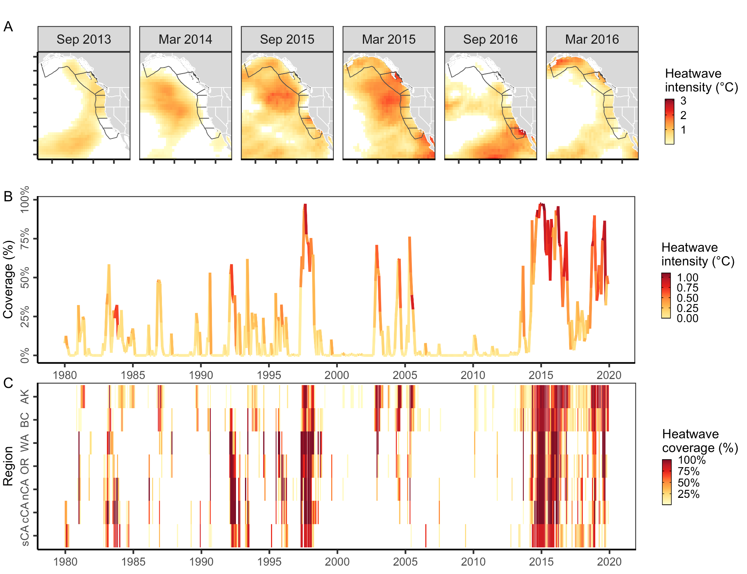**Figure 1.** History of marine heatwaves on the U.S. and Canada West Coast based on analysis of the COBE Sea Surface Temperature (SST) dataset [(Ishii et al., 2005)](https://www.zotero.org/google-docs/?QhSj1H). In **(A),** gray lines indicate the Exclusive Economic Zones of southern (sCA), central (cCA), and northern California (nCA), Oregon (OR), Washington (WA), British Columbia (BC), and the Gulf of Alaska (AK). The lower panels show the history of marine heatwaves **(B)** across these seven regions and **(C)** within each of the seven regions. Heatwave conditions were identified as temperatures above the 90% of the historical climatology (1980-2010) for a given month and raster cell [(Hobday et al., 2016)](https://www.zotero.org/google-docs/?iZrA1k); thus, heatwave intensity represents the difference between the observed temperature and the 90% heatwave threshold. In **(B)**, heatwave intensity is averaged across all cells experiencing heatwave conditions.

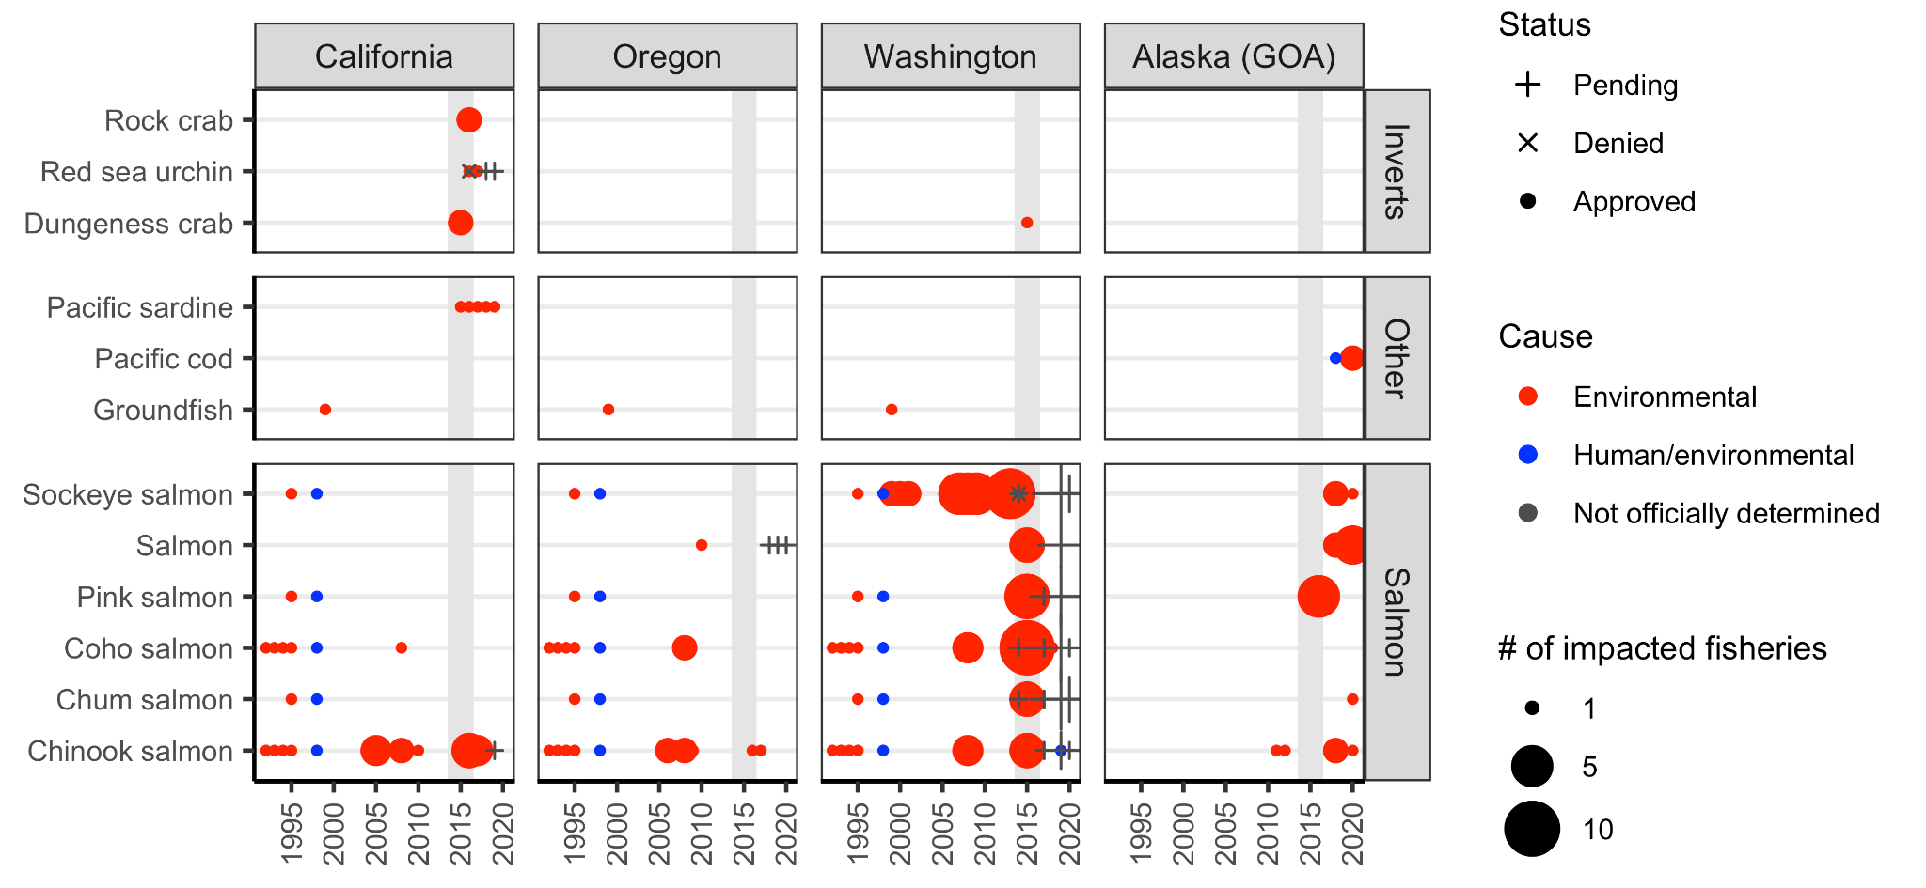

**Figure 2.** History of U.S. federal fisheries disaster declarations on the West Coast from 1989-2020 based on the database of [Bellquist et al. (2021)](https://www.zotero.org/google-docs/?k8iL7a). Gray shading indicates years of the 2014-16 marine heatwave. Disaster declarations for Alaska fisheries occurring outside the Gulf of Alaska (GOA) are excluded.

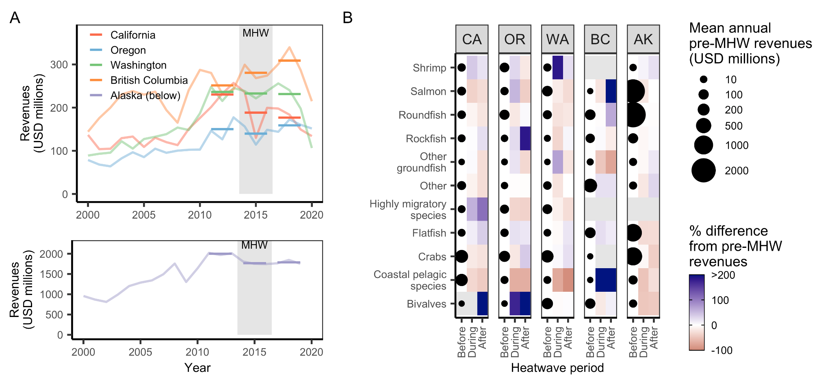**Figure 3.** Commercial fisheries revenues by **(A)** state and **(B)** state and management group before, during, and after the 2014-16 marine heatwave (MHW). In **(A)**, light lines indicate time series of total annual revenues and dark lines indicate the mean total annual revenue for years before (2011-13), during (2014-16), and after (2017-19) the heatwave. In **(B)**, the size of the points plotted in the “before” column indicate mean annual revenues during the years before the heatwave and the colors plotted in the “during” and “after” columns indicate the percent change in revenues relative to the years before the heatwave. Management groups are vertically ordered from greatest losses (bottom) to the greatest gains (top) in revenues during the heatwave averaged across states.

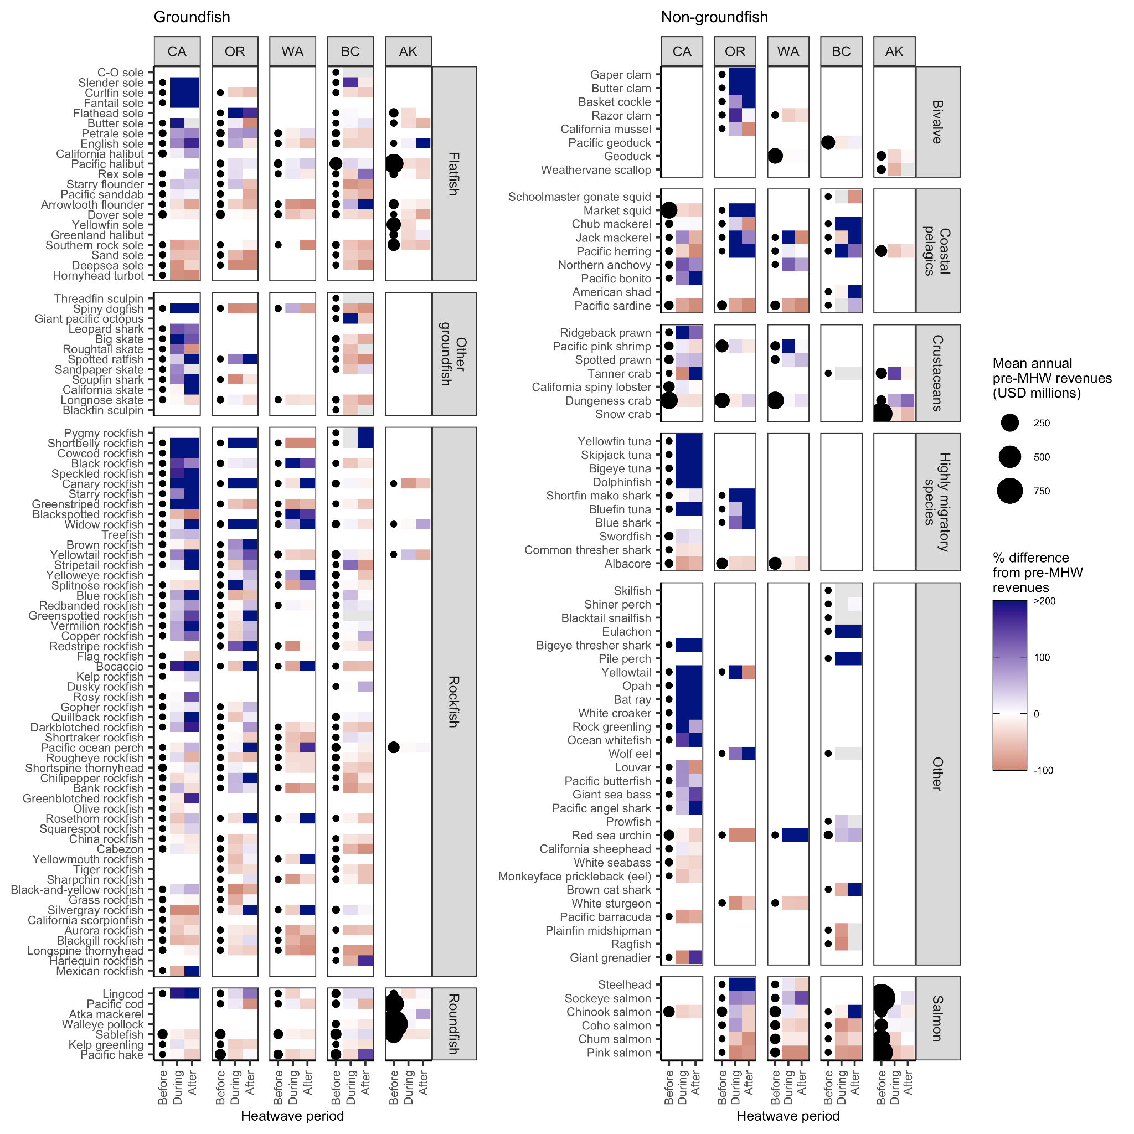

**Figure 4.** Commercial fisheries revenues before the 2014-16 marine heatwave and the percent change in revenues during and after the heatwave by state, management group, and species. Species (rows) are grouped by management group and are vertically ordered from greatest losses (bottom) to the greatest gains (top) in revenues during the heatwave averaged across states. The size of the points plotted in the “before” column indicate mean annual revenues during the years before the heatwave and the colors plotted in the “during” and “after” columns indicate the percent change in revenues relative to the years before the heatwave.

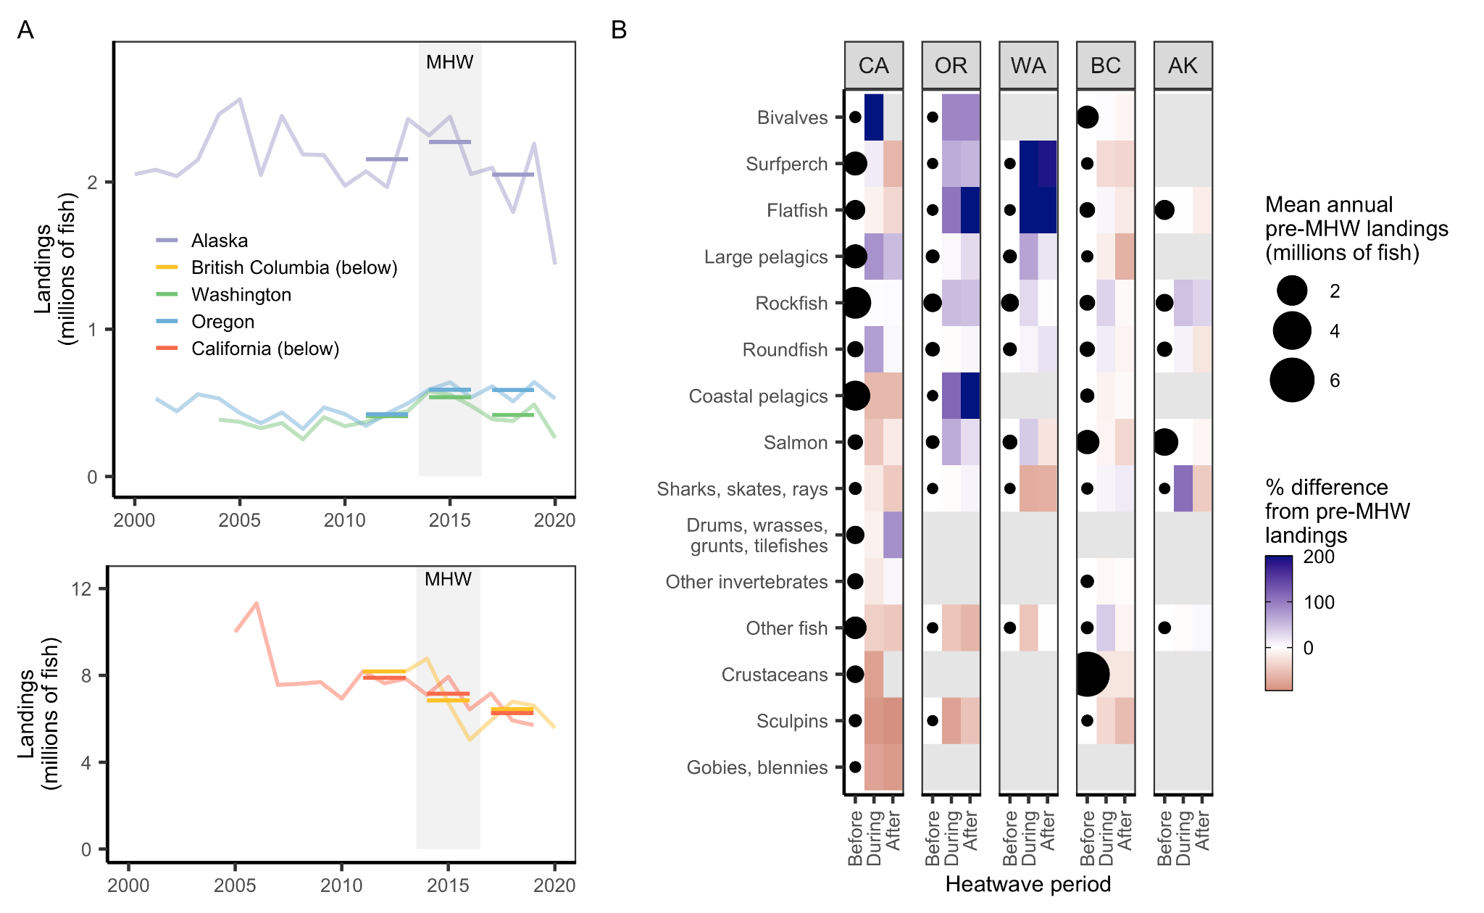

**Figure 5.** Recreational fisheries landings by **(A)** state and **(B)** state and taxonomic group before, during, and after the 2014-16 marine heatwave (MHW) based on multiple recreational landings databases. In **(A)**, light lines indicate time series of total annual landings and dark lines indicate the mean total annual landings for years before (2011-13), during (2014-16), and after (2017-19) the heatwave. In **(B)**, the size of the points plotted in the “before” column indicate mean annual landings during the years before the heatwave and the colors plotted in the “during” and “after” columns indicate the percent change in revenues relative to the years before the heatwave. Taxonomic groups are vertically ordered from greatest losses (bottom) to the greatest gains (top) in revenues during the heatwave averaged across states.

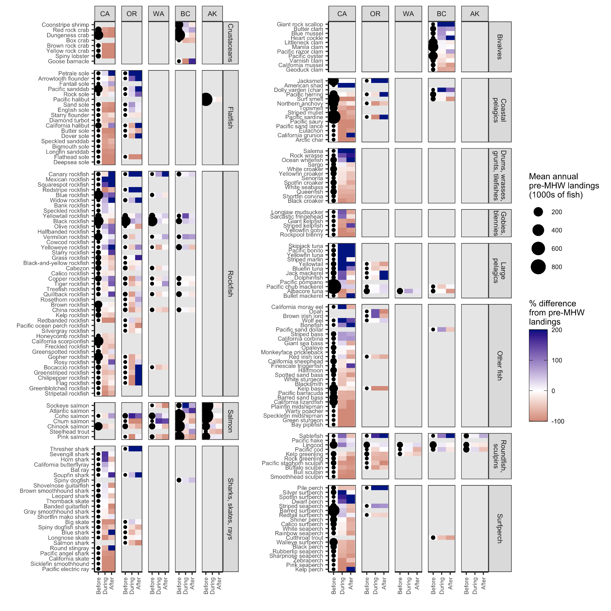**Figure 6.** Recreational fisheries landings (number of retained individuals) before the 2014-16 marine heatwave and the percent change in landings during and after the heatwave by state, management group, and species based on multiple recreational landings databases. Species (rows) are grouped by taxonomic group and are vertically ordered from greatest losses (bottom) to the greatest gains (top) in landings during the heatwave averaged across states. The size of the points plotted in the “before” column indicate mean annual landings during the years before the heatwave and the colors plotted in the “during” and “after” columns indicate the percent change in revenues relative to the years before the heatwave.

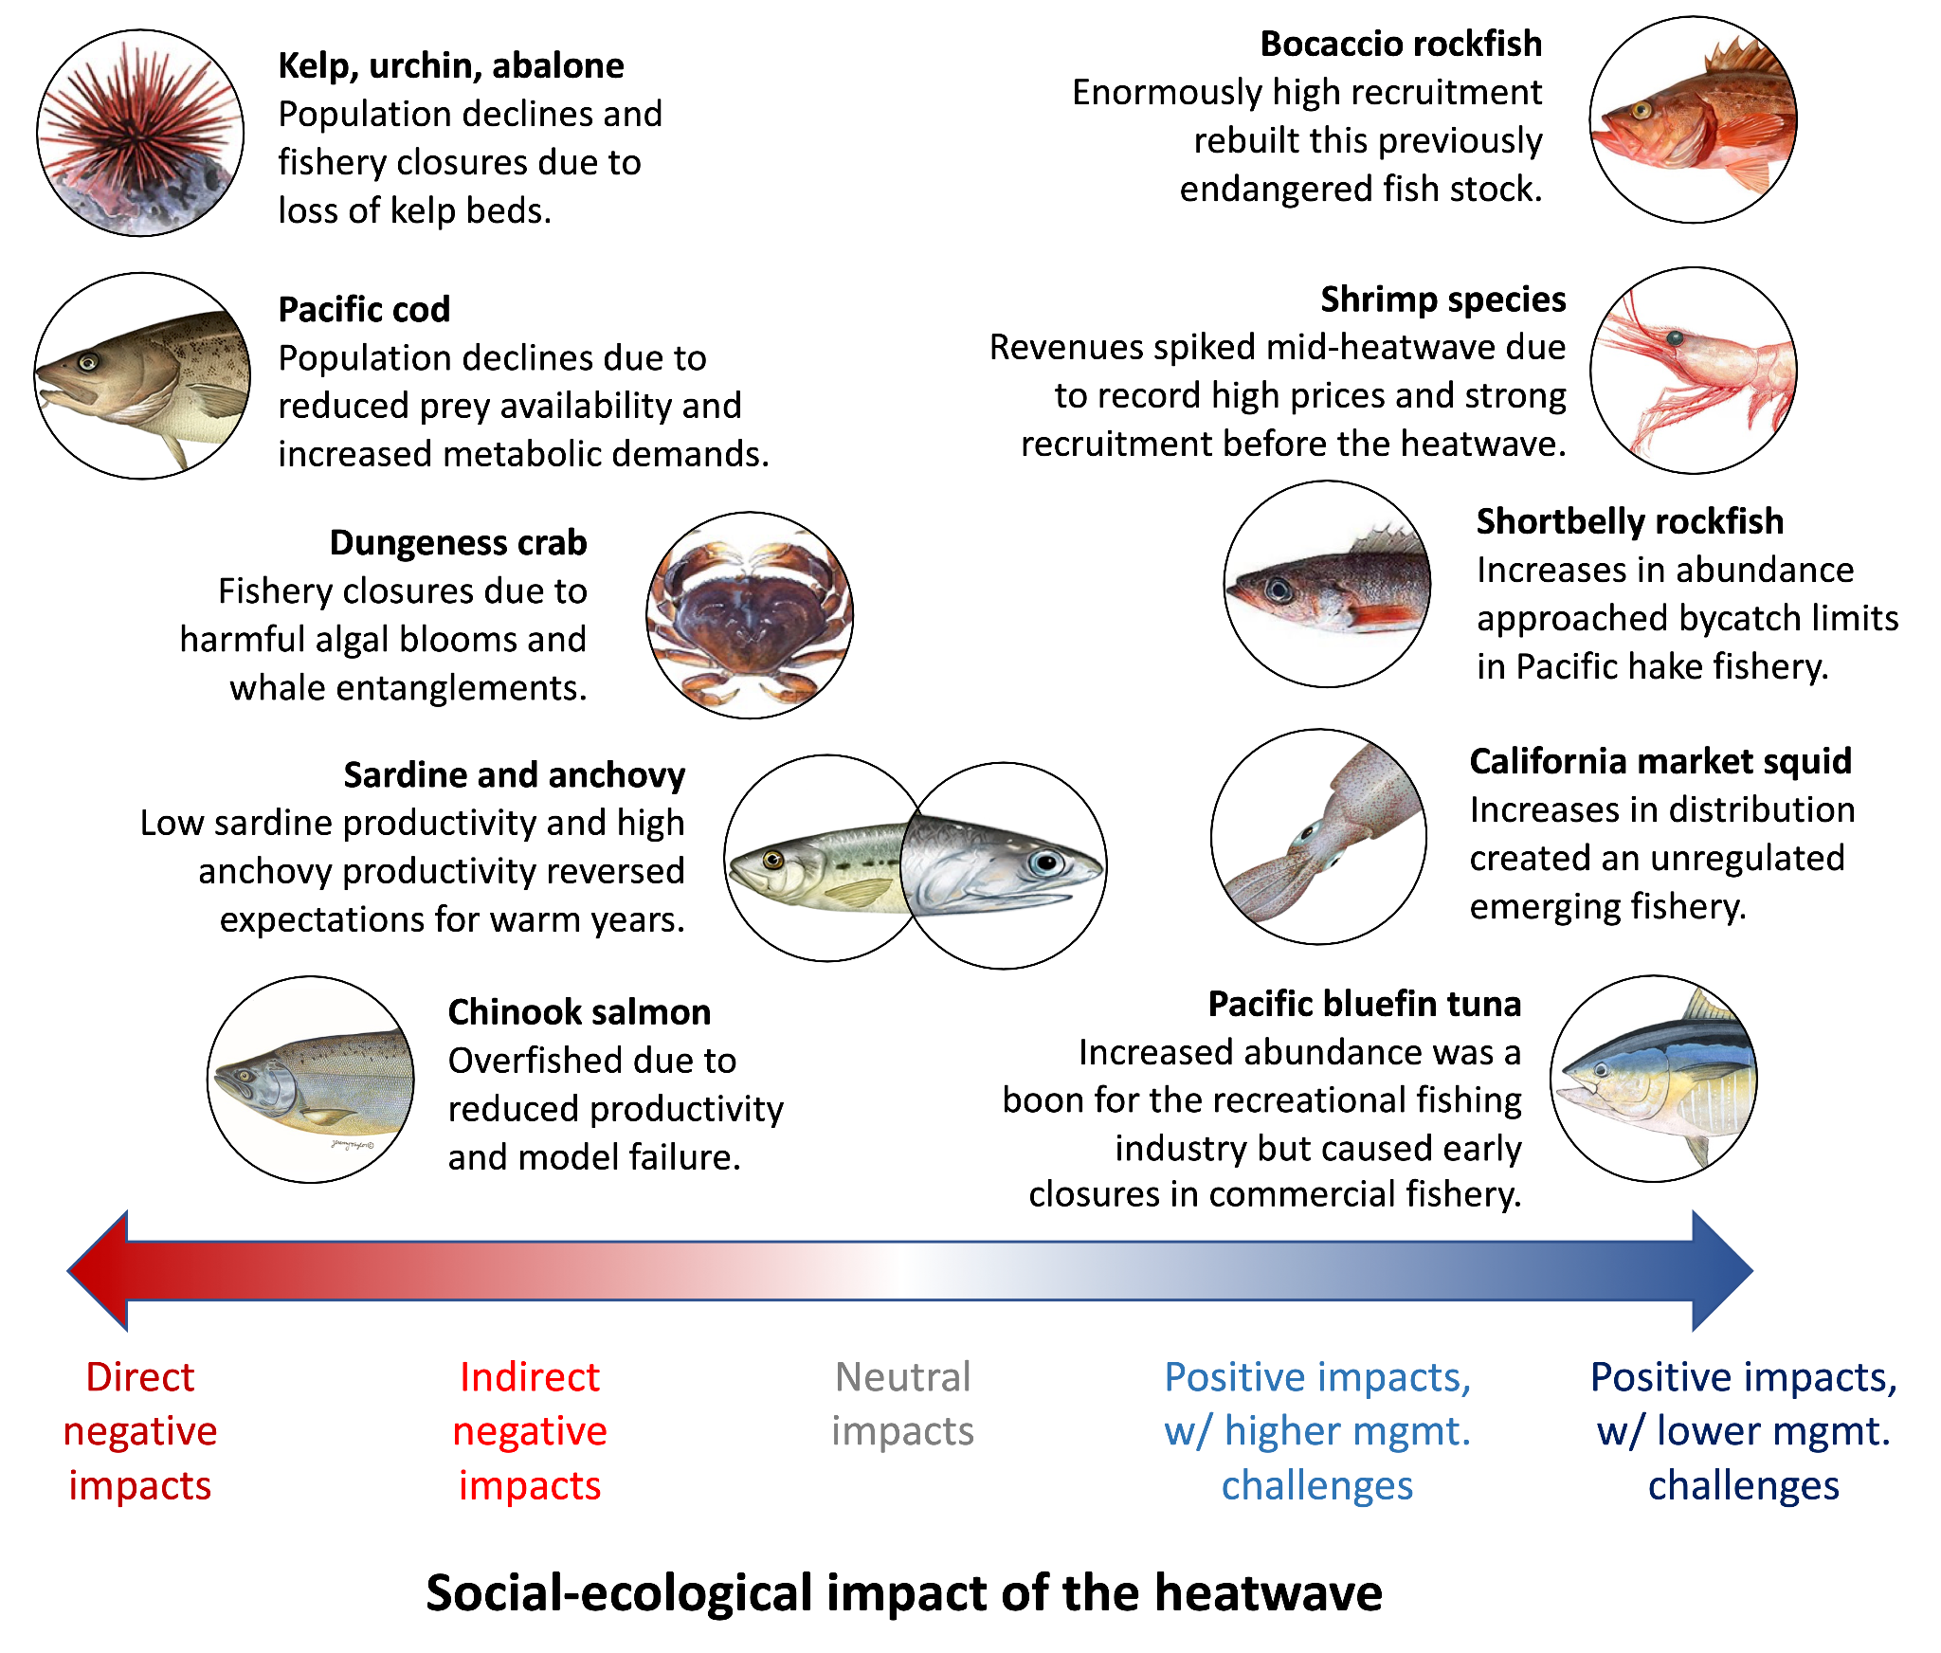**Figure 7.** Case studies evaluated in this paper. Case studies were selected to illustrate instructive examples of West Coast fisheries that experienced either positive (n=5) or negative (n=5) social-ecological impacts during the 2014-16 marine heatwave and to derive insights into improving monitoring, management, and adaptive capacity of communities to be more resilient to future heatwaves and climate change. Photo credits: NOAA (Pacific bluefin tuna, Pacific sardine, Pacific cod, California market squid, northern anchovy), CDFW (Chinook salmon, Dungeness crab, Pacific pink shrimp, red sea urchin), and WDFW (shortbelly rockfish).

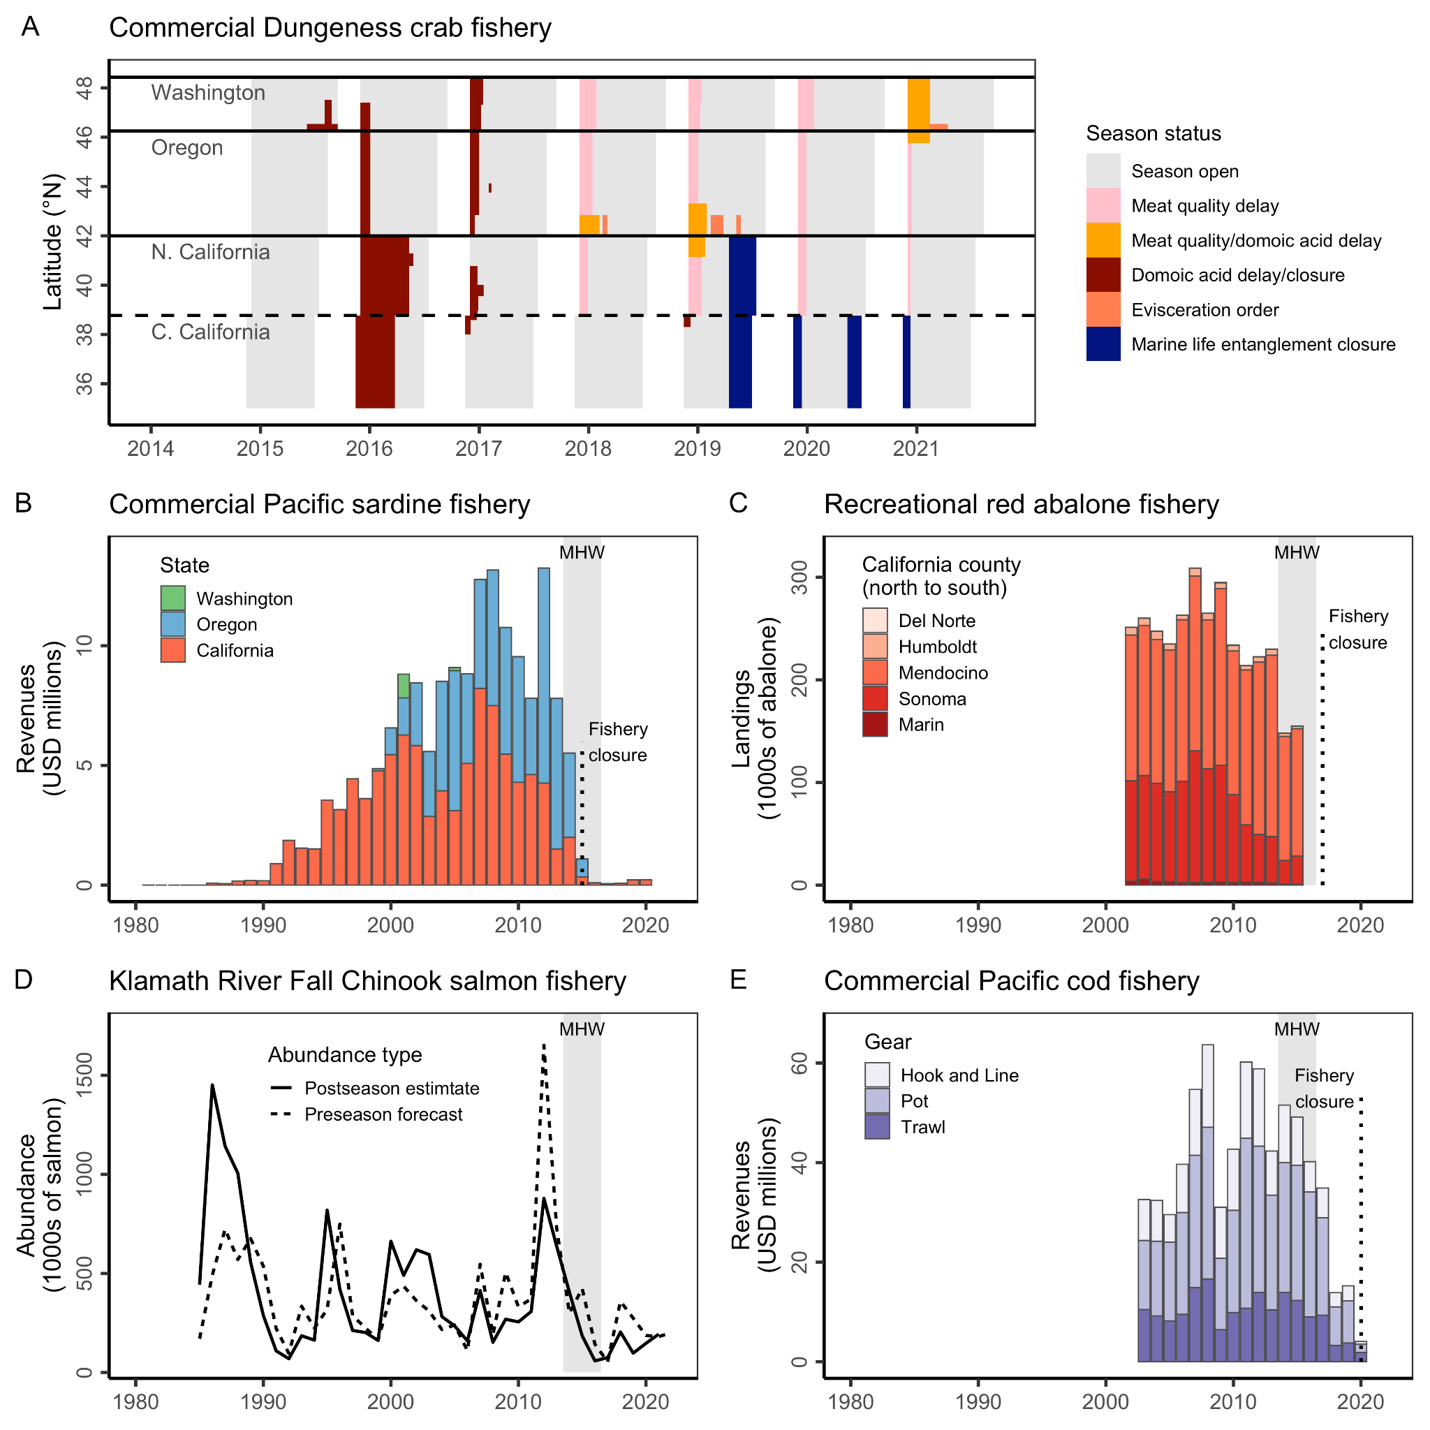**Figure 8.** Illustrations of some of the negative ecological and economic impacts of the 2014-16 marine heatwave. Panel **A** shows the history of closures to the commercial Dungeness crab fishery due to domoic acid contamination, whale entanglement, and meat quality. Panel **B** shows the collapse of the commercial Pacific sardine fishery and its closure during the heatwave. Panel **C** shows the collapse and closure of the recreational red abalone fishery during the heatwave. Panel **D** shows the collapse of the commercial Klamath River Fall Chinook salmon fishery after the marine heatwave and the contribution of overly optimistic model forecasts. Panel **E** shows the collapse of the commercial Pacific cod fishery in the Gulf of Alaska after increased adult mortality and reduced juvenile recruitment during the heatwave.

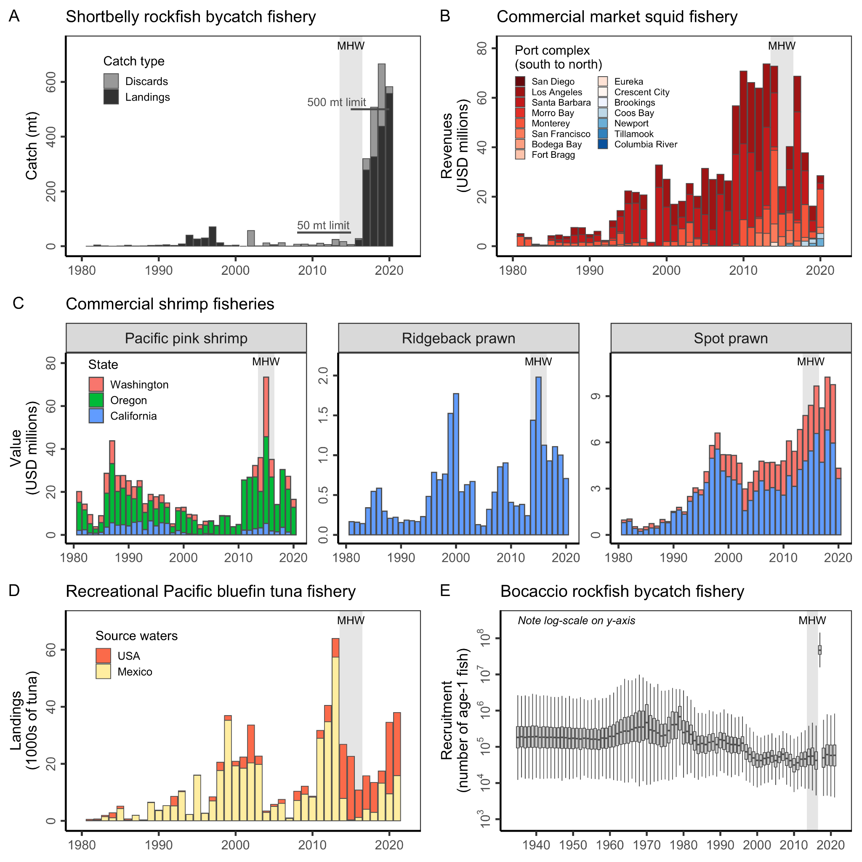

**Figure 9.** Illustrations of some of the positive ecological impacts of the 2014-16 marine heatwave. Panel **A** illustrates the explosion in shortbelly rockfish bycatch following anomalous recruitment during the heatwave. Panel **B** illustrates the persistent northward shift of California market squid landings initiated during the heatwave. Red colors indicate port complexes in California and blue colors indicate port complexes in Oregon. Panel **C** illustrates the spike in revenues in the commercial Pacific pink shrimp and ridgeback prawn fisheries during the heatwave and the continued growth of the commercial spot prawn fishery through the heatwave. Panel **D** illustrates the increased availability of Pacific bluefin tuna in U.S. waters during the heatwave. Panel **E** illustrates how the enormous spike in British Columbia bocaccio recruitment is projected to lead to the rebuilding of this endangered stock. In the boxplots, the solid line indicates the median, the box indicates the interquartile range (IQR; 25th to 75th percentiles), the whiskers indicate 1.5 times the IQR. Note the log-scale.

## Supplemental Information

### Supplemental methods

This paper compiles several datasets to illustrate impacts of the 2014-16 marine heatwave on fisheries of the U.S. and Canada West Coast. We describe the compilation of these datasets below.

**Federal fisheries disaster data**

The federal fisheries disaster data was developed by Bellquist et al. (2021).

**Commercial revenues data**

We used annual statewide fisheries revenue data to evaluate impacts of the heatwave on commercial fisheries. To create this dataset, we combined data from a few sources. We used annual revenue data from the PacFIN database for the U.S. West Coast (California, Oregon, and Washington) and data from the NOAA FOSS database for Alaska. We used data from the NOAA FOSS database rather than from the AKFIN database (i.e., the equivalent of PacFIN for Alaska) for Alaska because the AKFIN database only includes crabs and groundfish (i.e., it is less comprehensive) and is not species-specific (i.e., it is more generic). The NOAA FOSS database is more comprehensive and species-specific. While we could have also used the NOAA FOSS database for the other West Coast states, we preferred to use PacFIN because it’s closer to the raw data (i.e., NOAA FOSS is built using PacFIN data). We used annual revenue data provided directly by Fisheries and Oceans Canada (DFO) for British Columbia.

**Recreational landings data**

We used estimates of annual statewide fisheries landings (i.e., number of retained fish) to evaluate impacts of the heatwave on recreational fisheries. To create this dataset, we combined data from a few sources. We used estimates of annual landings from the RecFIN database for the U.S. West Coast (California, Oregon, and Washington) and from the ADFG website for Alaska. However, the RecFIN data does not include catches of highly migratory species in California’s for-hire (Commercial Passenger Fishing Vessel or CPFV) fleet. Thus, we used data from the CDFW Landings Reports for these species. We used the ADFG database for Alaska because the AKFIN database does not include recreational landings estimates. Although the NOAA FOSS database includes estimates of recreational landings by state, these estimates have been transformed into biomass (pounds) and are thus less representative of the original data. Furthermore, they do not include recreational landings estimates for Alaska.

**Case study time series data**

Dungeness crab management history: We obtained the spatial-temporal history of the Dungeness crab fishery shown in **Figure 8A** from Free et al. (2022).

Pacific sardine revenues data: We obtained time series of commercial Pacific sardine fisheries revenues from the PacFIN database [(PSMFC, 2021)](https://www.zotero.org/google-docs/?Z3BZKD), as compiled in the CALFISH database [(Free, Vargas Poulsen, et al., 2022)](https://www.zotero.org/google-docs/?ZzzewS).

Red abalone landings data: We obtained time series of recreational red abalone landings estimates from a CDFW report [(CDFW, 2015)](https://www.zotero.org/google-docs/?TTGbfm). CDFW estimated these values using abalone “report cards” (i.e. creel survey) and telephone surveys [(Kalvass & Geibel, 2006)](https://www.zotero.org/google-docs/?lBKE4W).

GOA Pacific cod revenues data: We obtained time series of commercial Gulf of Alaska (GOA) Pacific cod fisheries revenues by gear and subarea from the AKFIN database.

Klamath River Fall Chinook escapement forecasts and observations: We obtained time series of Klamath River Fall Chinook salmon pre-season escapement forecasts and post-season escapement observations from the 2022 pre-season report [(PFMC, 2022)](https://www.zotero.org/google-docs/?wpqXsW).

Shortbelly rockfish bycatch data: We obtained time series of shortbelly rockfish landings and discard estimates from the Groundfish Expanded Mortality Multiyear (GEMM) [(Somers et al., 2020, 2021)](https://www.zotero.org/google-docs/?Gh3lxw).

Market squid revenues data: We obtained time series of commercial market squid fisheries revenues by port complex from the PacFIN database [(PSMFC, 2021)](https://www.zotero.org/google-docs/?IKrkWu), as compiled in the CALFISH database [(Free, Vargas Poulsen, et al., 2022)](https://www.zotero.org/google-docs/?skL8eQ).

Pacific bluefin tuna landings data: We obtained time series of Pacific bluefin tuna landings by California’s recreational for-hire fleet from the California Marine Logbook System (MLS). The data query was submitted and processed by a co-author who is a CDFW employee.

Bocaccio recruitment time series: We obtained time series of Bocaccio rockfish recruitment estimates from the first author of the most recent bocaccio rockfish stock assessment [(DFO, 2021)](https://www.zotero.org/google-docs/?Lzxykj).

### Supplemental figures

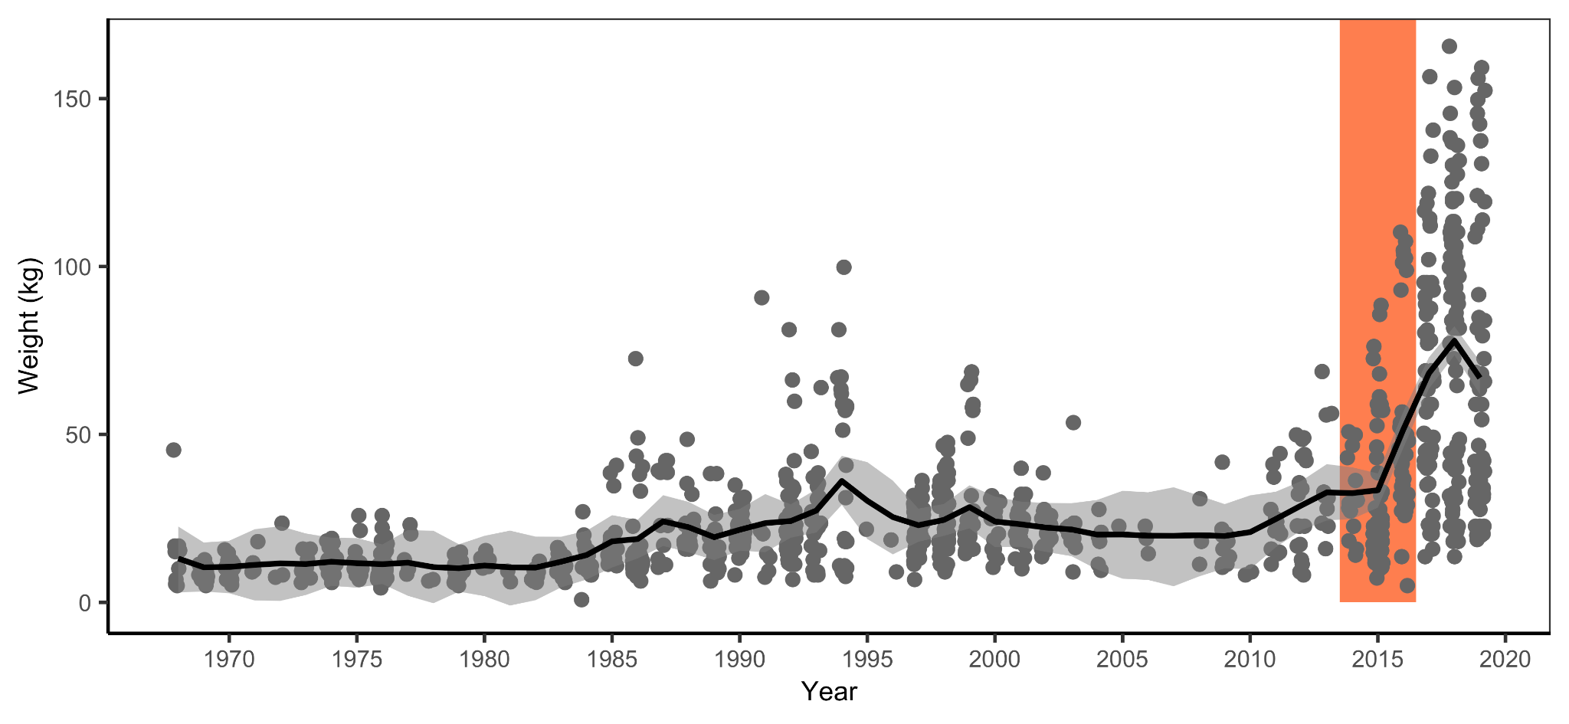**Figure S1.** Time series of trophy size Pacific bluefin tuna reported in the “Whoppers of the Week” section of Western Outdoor News from 1968-2019. The vertical orange rectangle illustrates the 2014-16 marine heatwave. The black line and shading indicate the median and 95% confidence interval of a state-space model fit to the data. The data and modeling framework are an extension of that published in [Bellquist et al. (2016)](https://www.zotero.org/google-docs/?JLSfjY).